Getting Started with Campaigns
Campaign Types
There are 6 types of campaigns that can be run in IFS. They are:
- Buy and Get Campaign – e.g. Buy 2 and get 1 free
- Receive discount by purchasing a given amount in Tk. – e.g. Save BDT 500 by purchasing Tk.6000 or more.
- Lower Price of Articles for a Campaign (offer lower price of articles for a given period of time)
- Give discounts to specific customers using IDs – e.g. Loyal customers.
- Gift Vouchers (Institutional Customers) – Issue a gift voucher with a discount % or amount (in TK). E.g. Issue a Tk. 1000 gift voucher for Director of Padma Oil.
- Using Price Lists for Institutional Customers under Wholesale
- Appendices
Please note that there are also circular discount campaigns, which are not covered in this manual. Additionally, each of the campaign types have a set of rules governing them (called Campaign Policies). It is strongly advised that you go through them before designing any campaigns on your own.
In this manual we will provide a step by step guide on how to create, edit and activate each of the 6 types of campaigns. It is possible to create a wide variety of campaigns using these 6 basic types.
Before designing any campaigns, please ensure that the following conditions are fulfilled:
- Note down the articles that will be a part of the campaign. The start and end date of the campaign, as well which Galleries / Depots will be a part of the Campaign.
- The sites included in the campaign already have the articles in the required quantities that are needed in the campaign.
- The gift item that will be given in the campaign has already been defined as a Sales, Purchase and Inventory Part along with its price.
- For loyal customers or institutional customers, please ensure that the customer has already been entered into the IFS database from the Finance department.
- The reference site is U2CDC
- Ensure that the articles included in the campaign are not already a part of any other on-going campaigns. This will create a logic error in POS.
- After the campaign has been finalized and approved, send the campaign to POS for Galleries. For Depots, just select Activate.
- LOV is short for List of Values which can be accessed from the side panel or using F8.

A. Buy and Get Campaign
The Campaign example we will practice with is a simple one. Buy 1 pair of Venturini Shoes (91111A67) and receive 1 pair of Nino Rossi sandals (72510A8235) Free (i.e. at 100% discount). The Campaign ID is 20. Please note both article numbers and down for reference.
Campaign Module Path: Sales > Pricing > Campaign
- F5 or select NEW.
- Type in campaign description (max 50 characters).
- Put in your coordinator name (if it is already not shown).
- Reference site will be U2CDC (can be typed or selected from the LOV).
- Select the appropriate retail assortment using the LOV (in this case it is A01).
- Double Click on the Sales Start Date and use the Calendar to select the start date of your campaign.
- Double click on the Sales End Date to select the end date of your campaign.
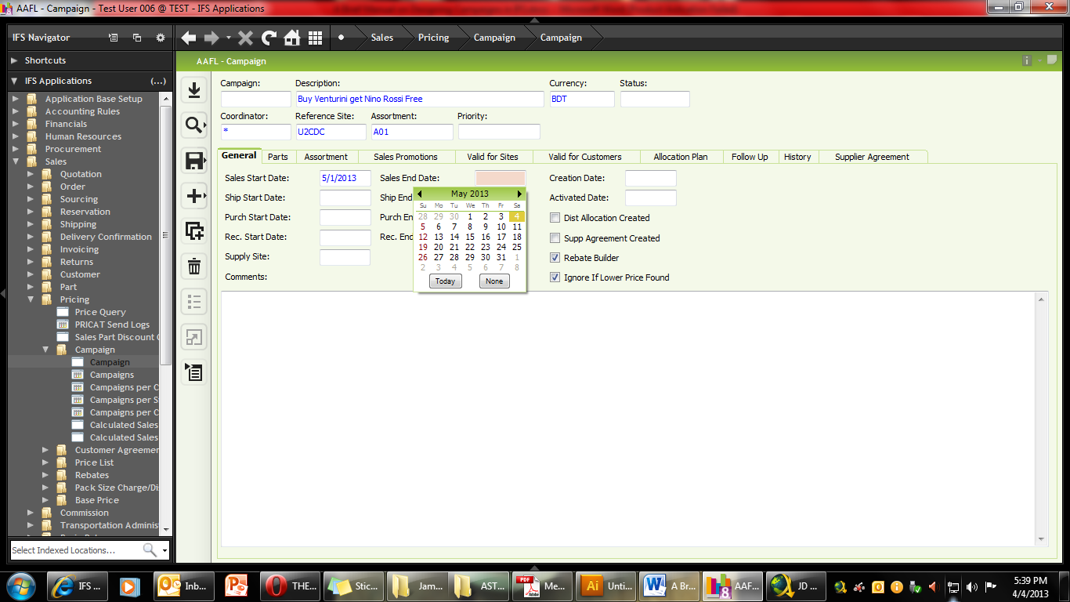
- SAVE (shortcut Ctrl+S). You will notice that the Campaign Number (ID) is automatically generated.
- Now Click the Sales Promotions Tab to enter all the articles and gifts for the campaign.
- Select DEAL ID and click NEW (F5).
- Copy the Campaign Description and enter it in the DEAL ID descriptions tab (Max 50 characters).
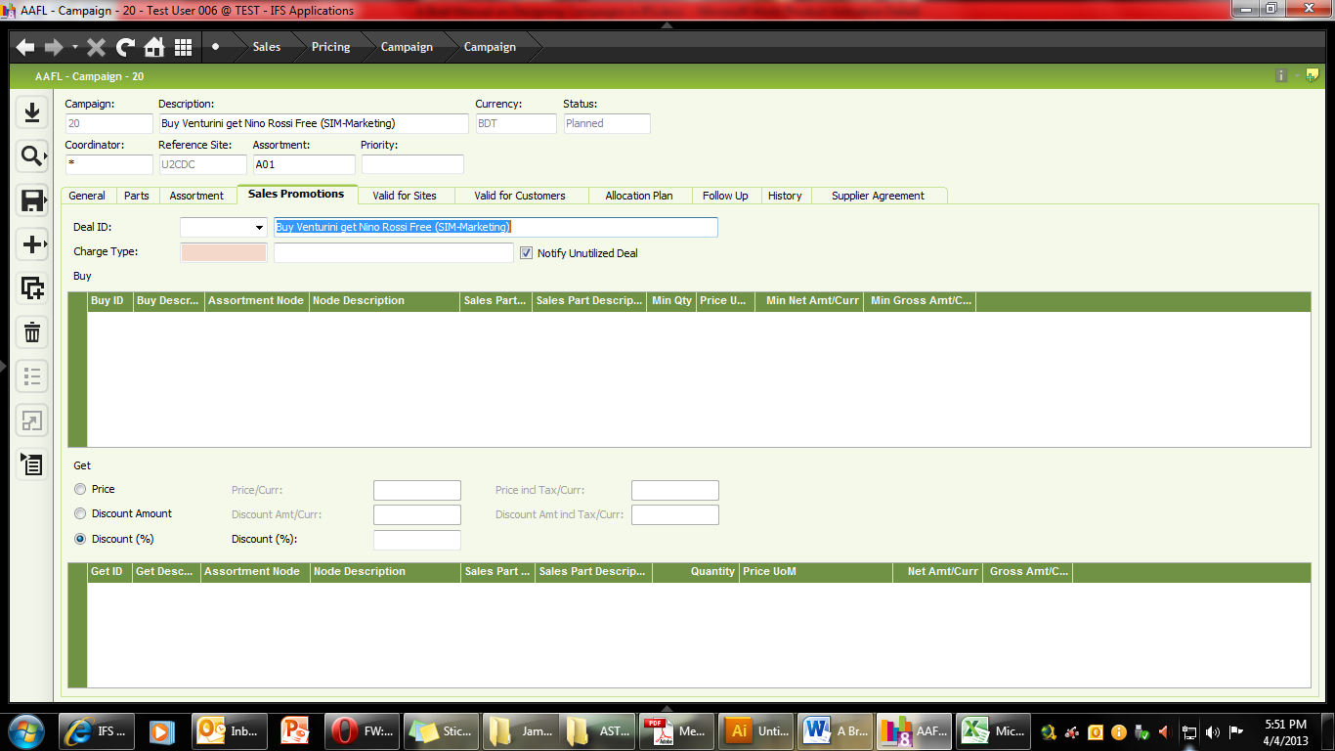
- Make sure “Notify Unused Deal” is ticked.
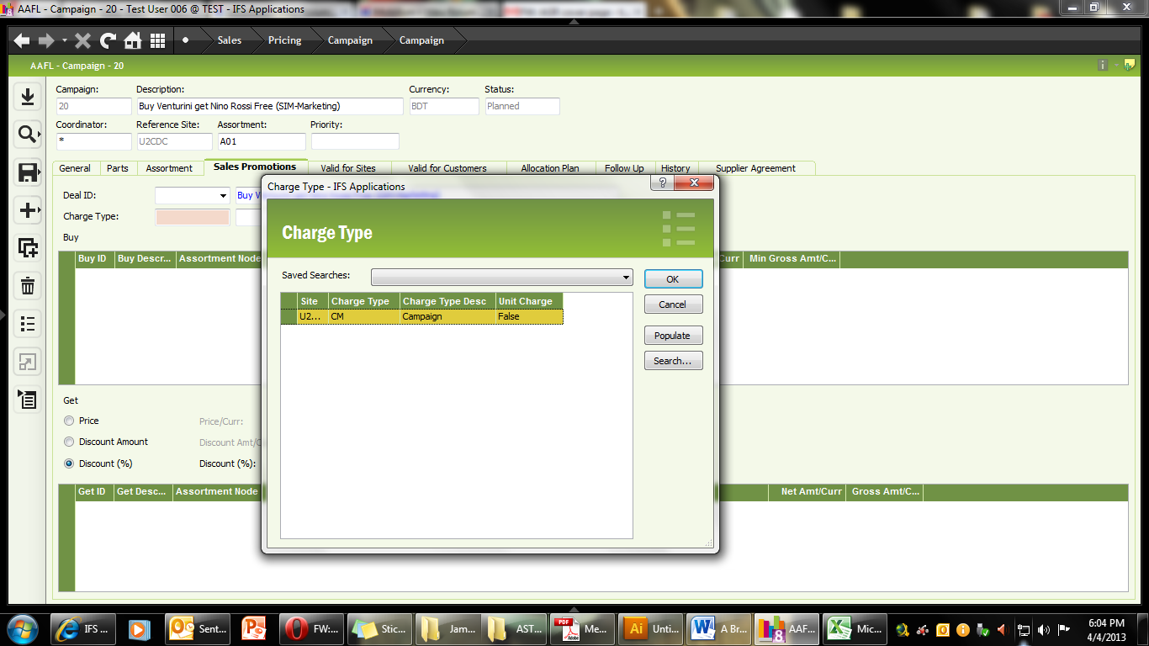
- Select the appropriate campaign charge from the LOV.
- For Marketing Department, the Charge type will be CM (Campaign Marketing).
- SAVE (notice that the color of the campaign description changes from BLUE to Grey).
Now we are ready to start adding parts relevant to the campaign. We will start by adding items to the BUY Window.
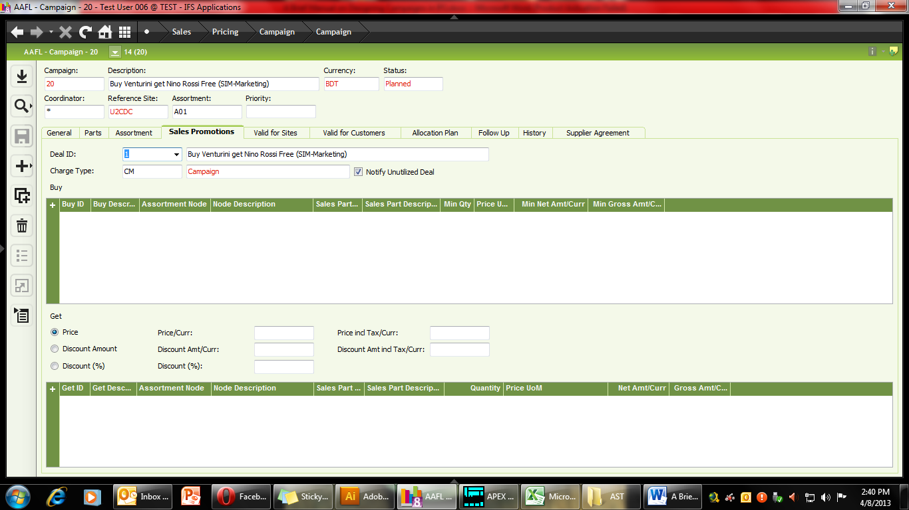
This window shows the articles that the customer must purchase in order to get the gift. Please note that if you enter more than one article, that will mean that the customer will have to purchase all articles in the list in order to get the free item.
Please ensure that the articles that you are entering in the campaign are already not a part of any other campaign. At any given point in time, one article can only be a part of one active campaign.
Retail Assortment Module: Part Catalogue > Retail Assortment > Assortment
- It is easy to add articles using the Retail Assortment Module (Part Catalogue > Retail Assortment > Assortment). Use F2 to populate list, and find the Assortment that is appropriate for you.
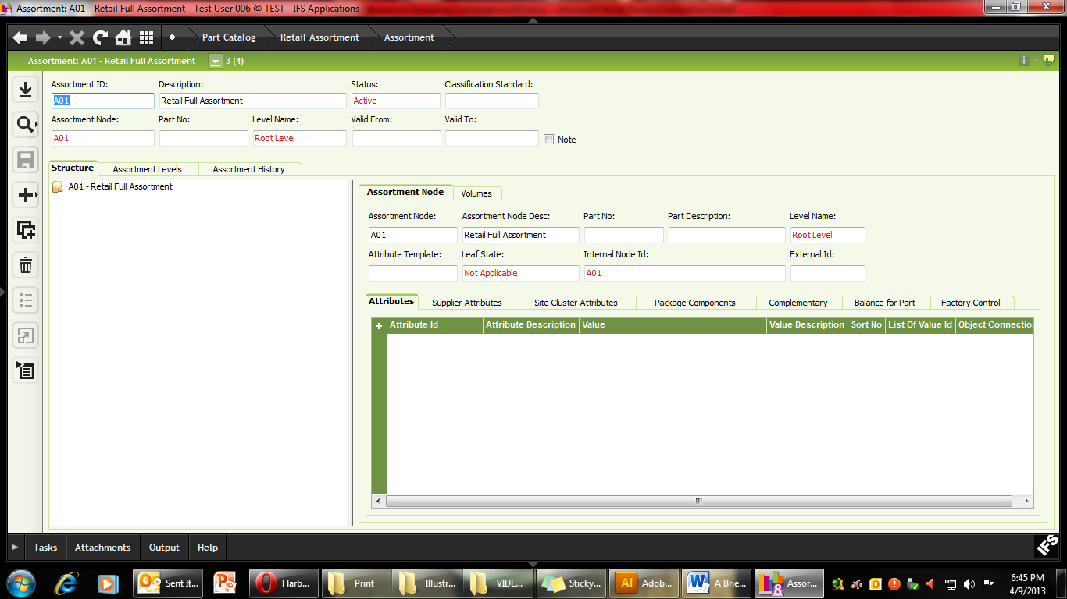
- In this Campaign we are use the Retail Assortment A01 (Full Retail Assortment). Please note this number down.
- Now using the BUY article code (in this case 91111A67) find the appropriate node (RMB> Expand). Do not click “Expand descendants” as this will take a long time to process the data.
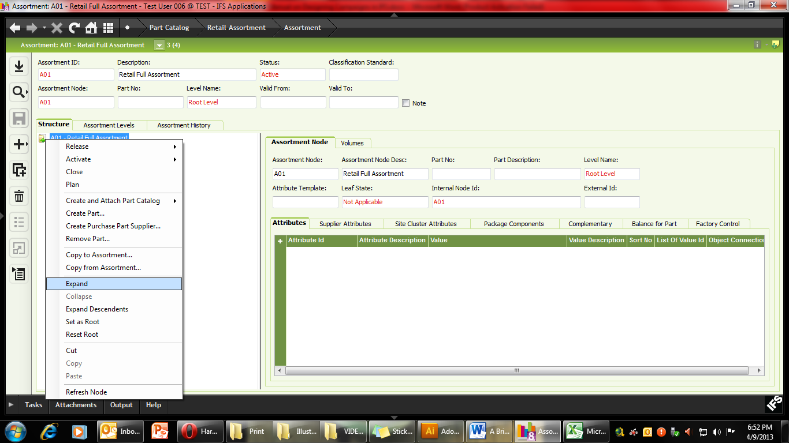
- Use the small “+” to navigate to the article using the article structure. In our case it is 9 (for men’s), 1 (Closed shoes), 1 (Smooth Leather), 1 (Black), 1 (Alteration), A (Grade), 67 (Design no).

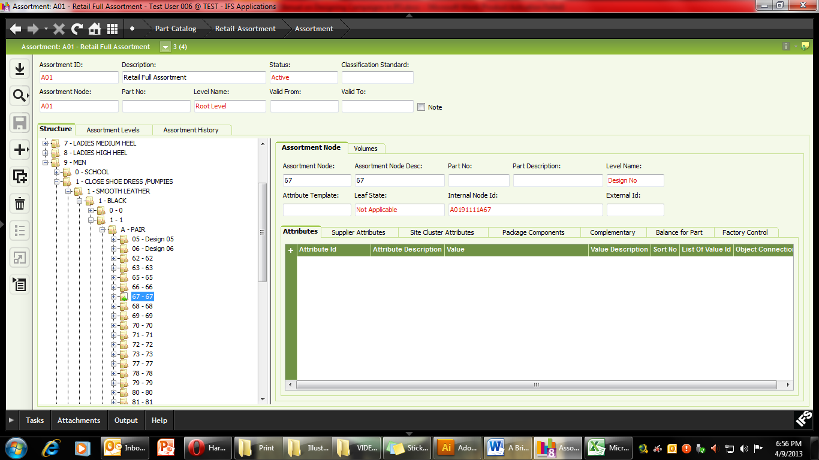
- Click on Design 67, then on the right hand side COPY the Internal Node ID (if you wish to ignore size). If you wish to only include a particular size to the campaign (and not the entire size assortment), then you will need to add each article individually and skip using the retail assortment altogether). Please note that the articles that are included in the campaign will depend on which level of the Retail Assortment you are copying the node from. E.g. If you copy the A0191 it means all men’s articles which are closed shoes (9,1) are a part of the campaign. If A019111 node was copied this would mean all men’s closed shoes with smooth leather and black color (9,1,1,1) will be a part of the campaign.
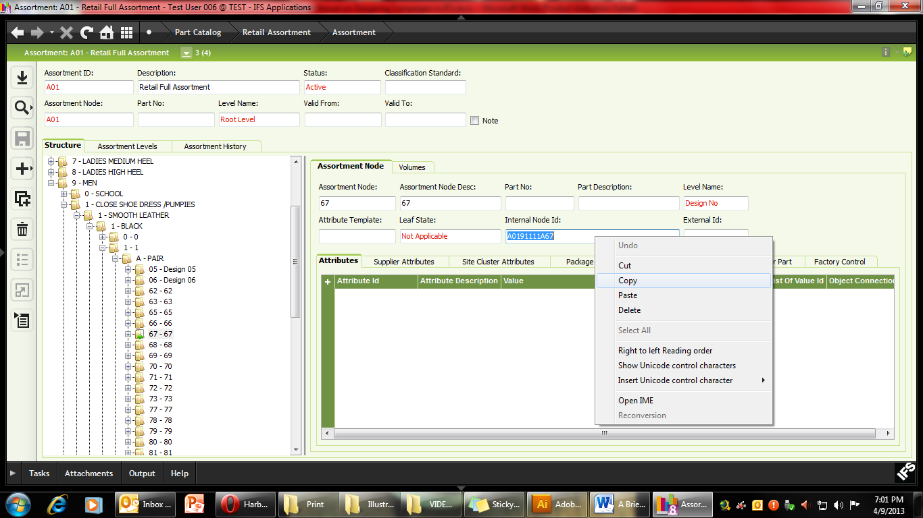
- Now using the Windows button, go back to the Campaign Window
- Under the BUY window, click the “+” sign and PASTE the NODE ID in the ASSORTMENT NODE FIELD.
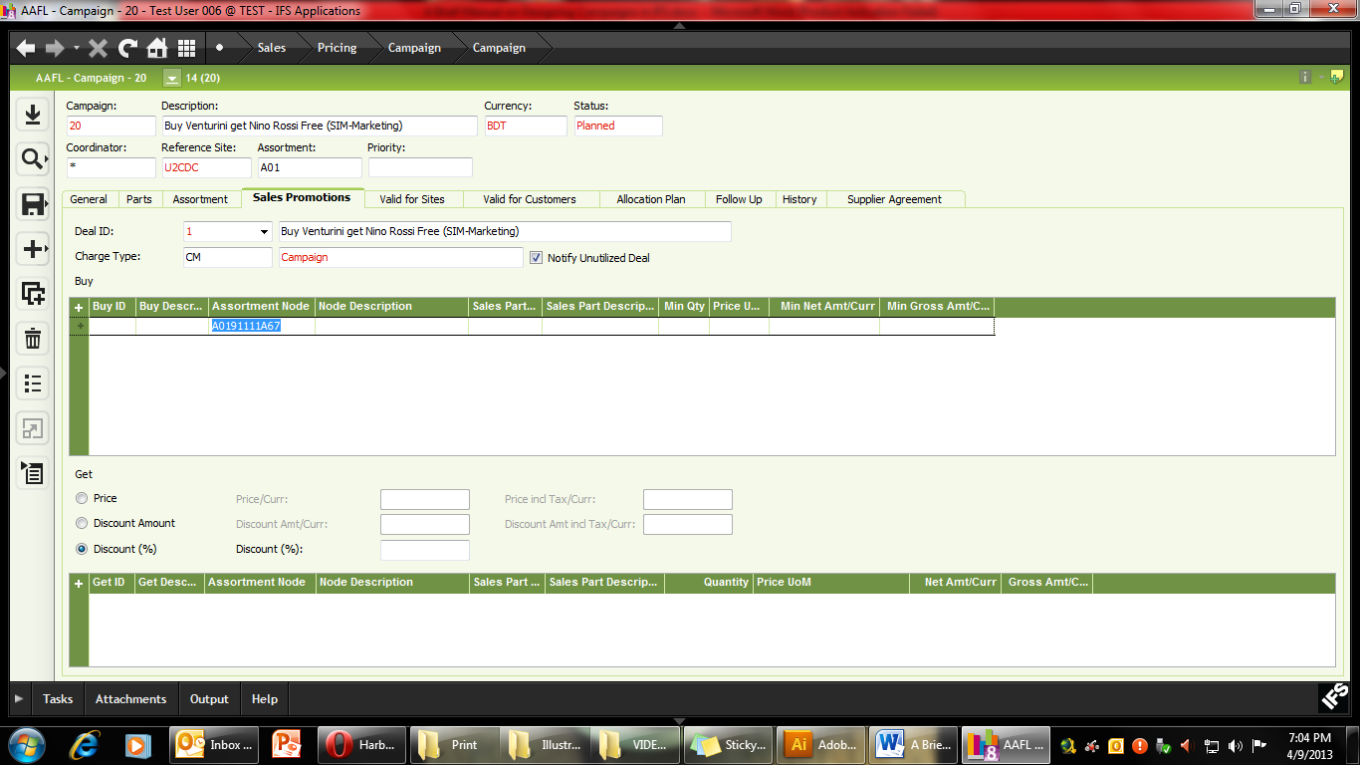
- Now enter the QTY (the minimum quantity the customer has to purchase to receive the Gift) and then include the UOM (unit of measure) and SAVE.
- Going back to the RETAIL ASSORTMENT MODULE, now navigate to the GET PART (72510A82) and copy the Internal Node ID
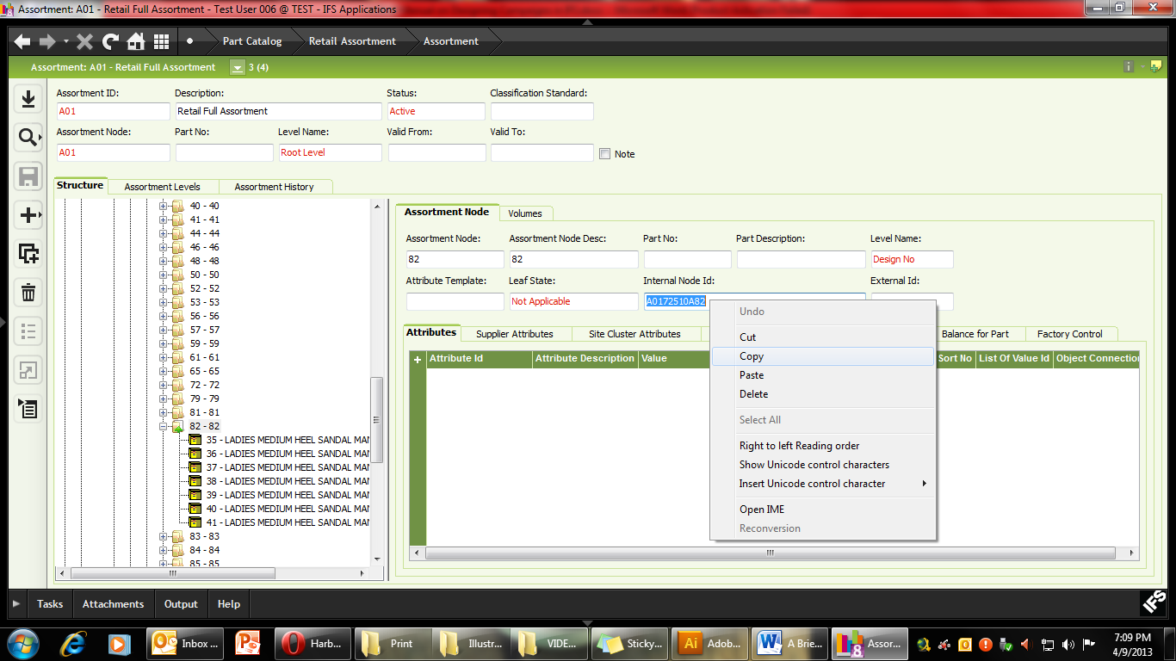
- Use the Windows Button to quickly switch back to the Campaign Module
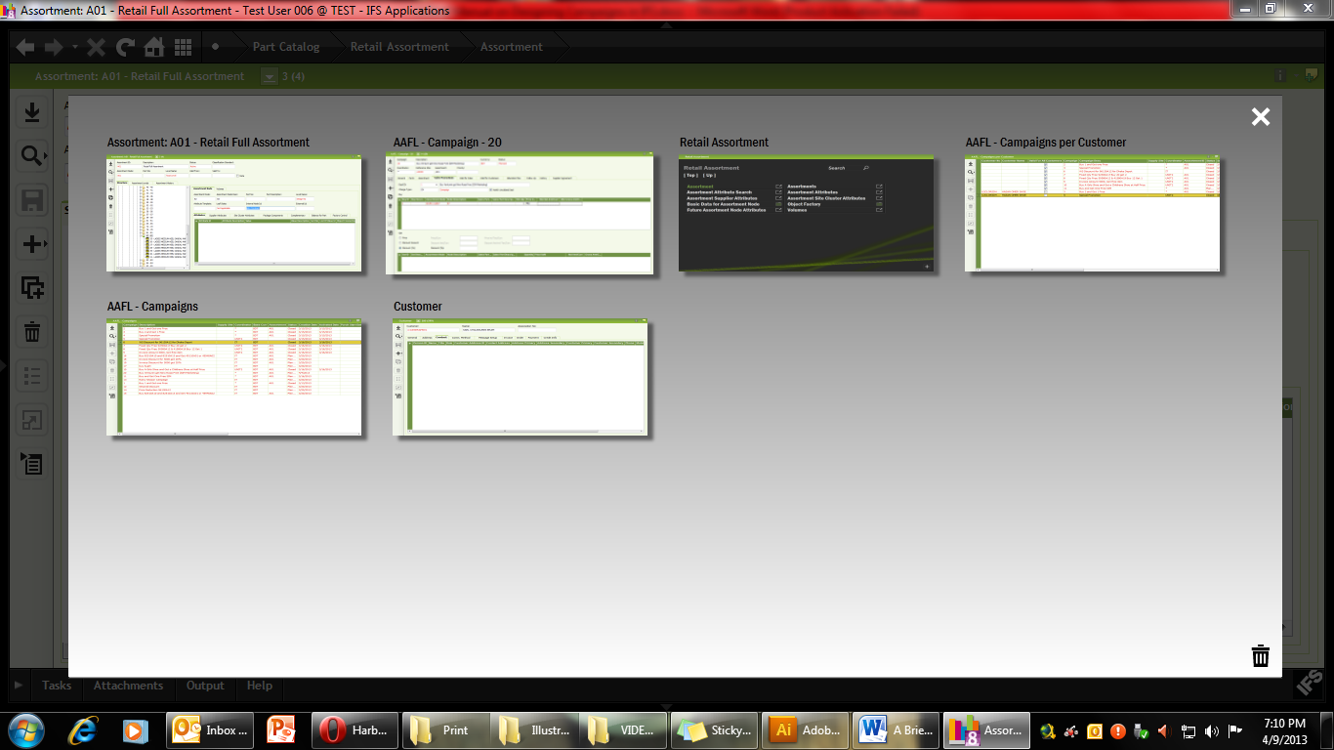

- Going back to the Campaign window, now click the “+” under Get Part and PASTE the Node ID in the Assrotment Node Form.
- Enter the Discount Percentage (in this case it is 100% since the women’s article will be given as free). Please note that it is also possible to give Discount Amount (instead of Percentage) if the campaign requires it. E.g. Get Tk.200 discount on Nino Rossi Sandals.
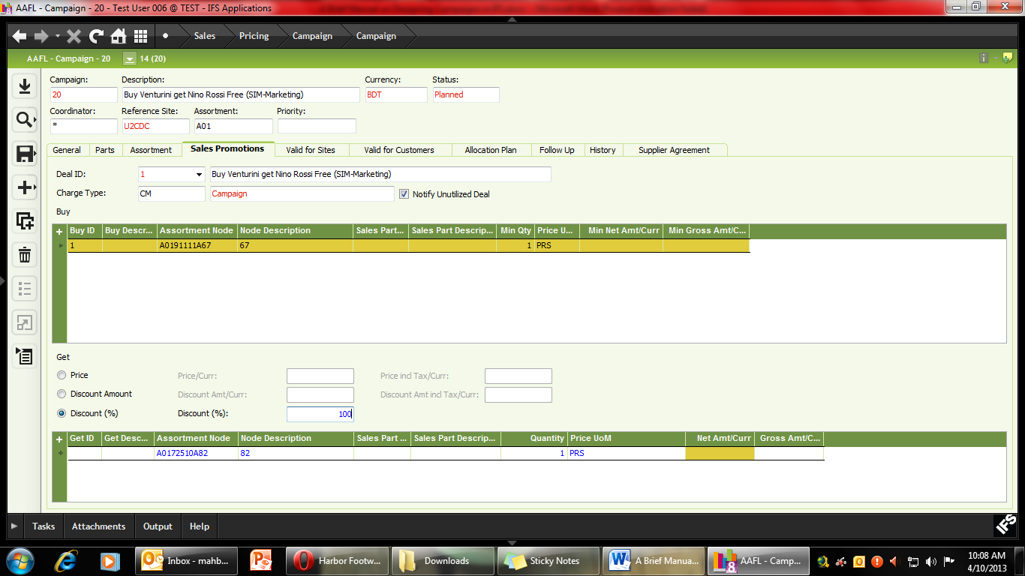
- SAVE the campaign.
- Now Select the Galleries / Depots that will be a part of the campaign using the “Valid for Sites” tab.
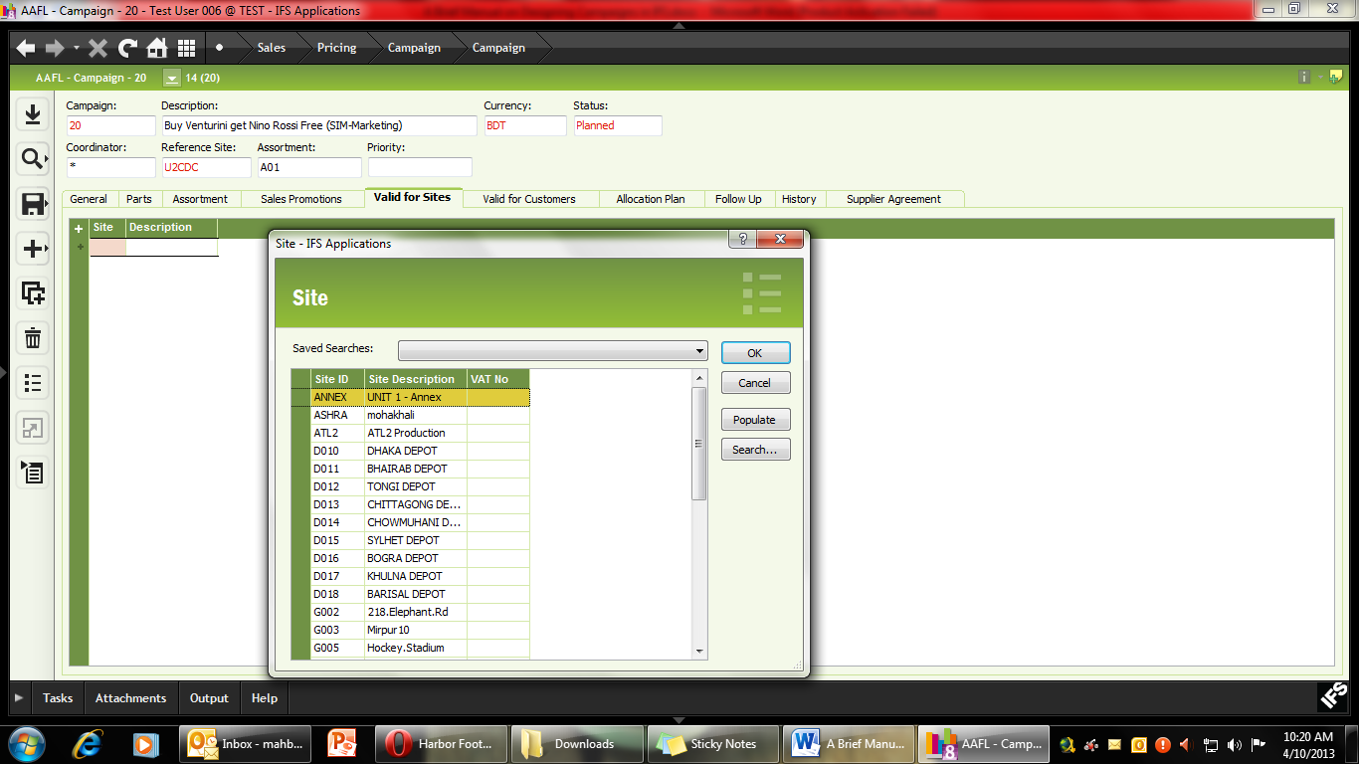
- Click the “+” sign and use LOV to find the sites that are a part of your campaign.
- In this Campaign, add Galleries G002 (Elephant Road). You can also simply type “G002” and Press TAB, and IFS should automatically input the appropriate Gallerie to the campaign.
- Press the “+” again and add G044 (Bashundhara City) to the campaign (either by typing G012 or selecting it from the LOV).

- Once all the Sites for the campaign has been entered, SAVE.
- Under the “Valid for Customer Tab” make sure that “Valid for All Customers” is checked. If the campaign is valid for only a specific group of customers, then each customer has to be entered individually.
- You campaign is now ready. Review all the information of the campaign again before activating the campaign.
- IF everything is correct, then move the cursor to the Field Header, RMB. For Depots simply select “Activate” and the campaign will run from the specified date. If the Campaign is for Galleries, then instead of Activate, select “Send to POS” option.
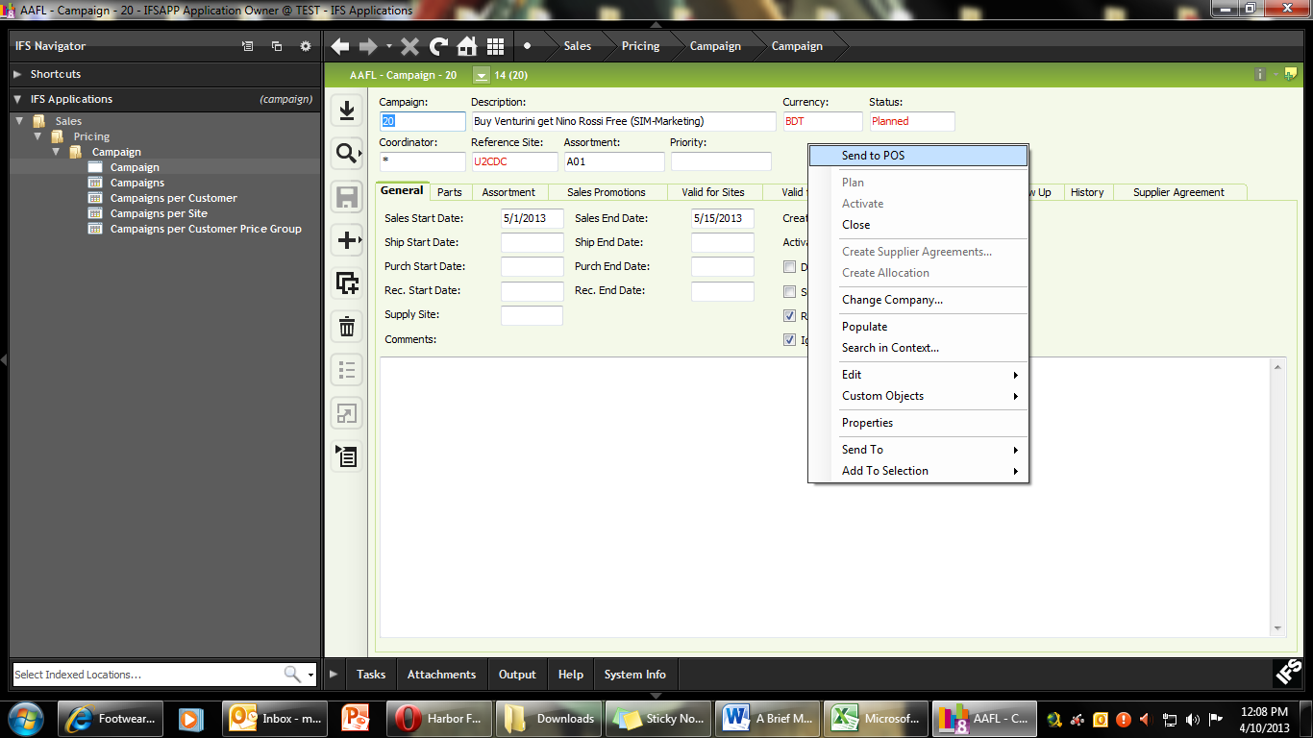
Please note that if you wish to stop the campaign, you will have to RMB and select “Close”. It is also important to note that if the articles included in the campaign are not in stock in the selected Galleries / Depots, you will not be able to Activate the campaign.
B. Receive Discount by purchasing a given amount
Buy purchase Tk. 5000 worth of Men’s shoes from selected outlets of Gallerie Apex, you will receive a pair of children’s shoes (41580A19) at 100% discount. This offer is valid for regular priced articles only (i.e. products which are already on discount will be excluded from this campaign). In POS there is an auto checking function to prevent discount articles from being included in such campaigns. For Depots however, this has to be checked manually. For any customer who wishes to purchase items which are already on discount, the discount articles have to be invoiced separately.
Campaign Module Path: Sales > Pricing > Campaign
- F5 or select NEW.
- Type in campaign description (max 50 characters).
- Put in your coordinator name (if it is already not shown).
- Reference site will be U2CDC (can be typed or selected from the LOV).
- Select the appropriate retail assortment using the LOV (in this case A01).
- Double Click on the Sales Start Date and use the Calendar to select the start date of your campaign.
- Double click on the Sales End Date to select the end date of your campaign.
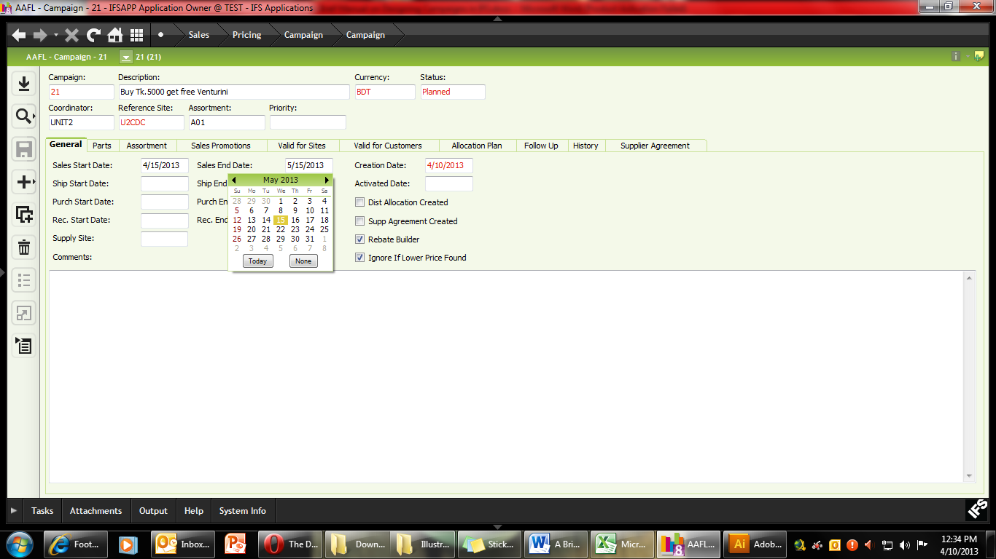
- SAVE (shortcut Ctrl+S). You will notice that the Campaign Number (ID) is automatically generated.
- Now Click the Sales Promotions Tab to enter all the articles and gifts for the campaign.
- Select DEAL ID and click NEW (F5).
- Copy the Campaign Description and enter it in the DEAL ID descriptions tab (Max 50 characters).
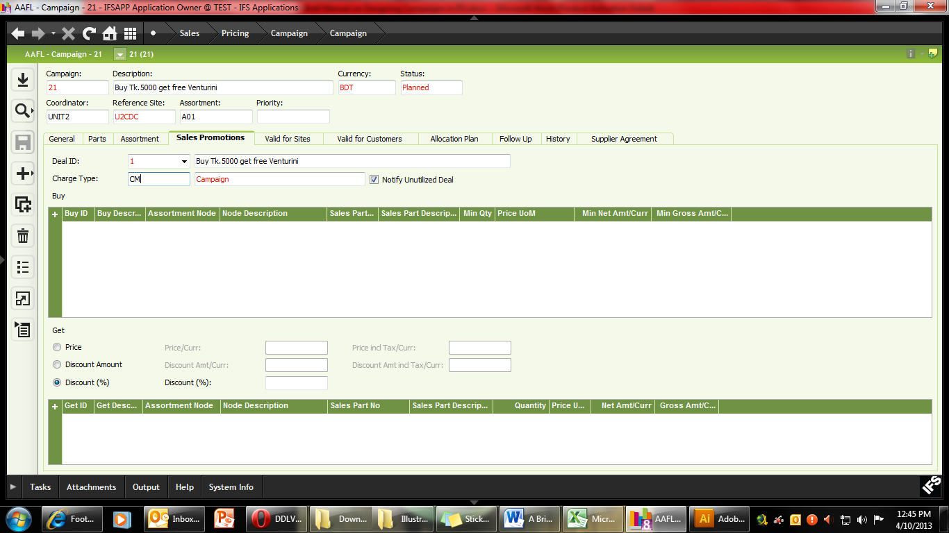
- Make sure “Notify Unused Deal” is ticked.
- Select the appropriate Campaign Charge from the LOV.
- For Marketing Department, the Charge type will be CM (Campaign Marketing).
- SAVE (notice that the color of the campaign description changes from BLUE to Grey).
Now we are ready to start adding parts relevant to the campaign. In this campaign we will include all MEN’S articles from the Retail Assortment A01.
Retail Assortment Module: Part Catalogue > Retail Assortment > Assortment
- Navigate to Retail Assortment and copy the NODE ID from the MEN’S Level of the assortment. Since we wish to include all articles under the Men’s line for the campaign.
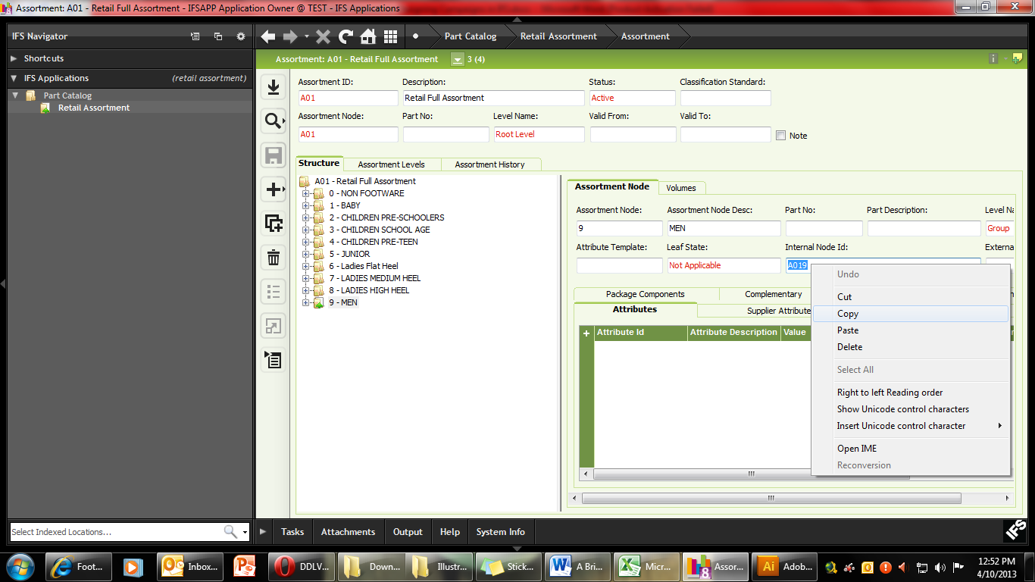
- Going back to the campaign now we can use the Sales Promotion Tab to enter the Node information.
- Click the “+” under the BUY window and Paste the NODE ID in the ASSORTMENT NODE field.
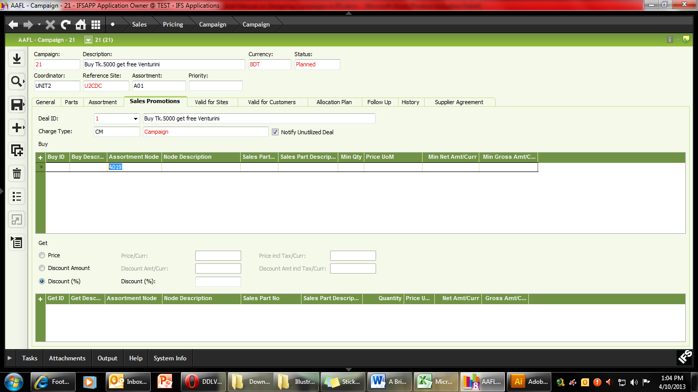
- Under Min Net Amt / Curr type “5000” (as in minimum purchase amount has to be Tk.5000 or more)
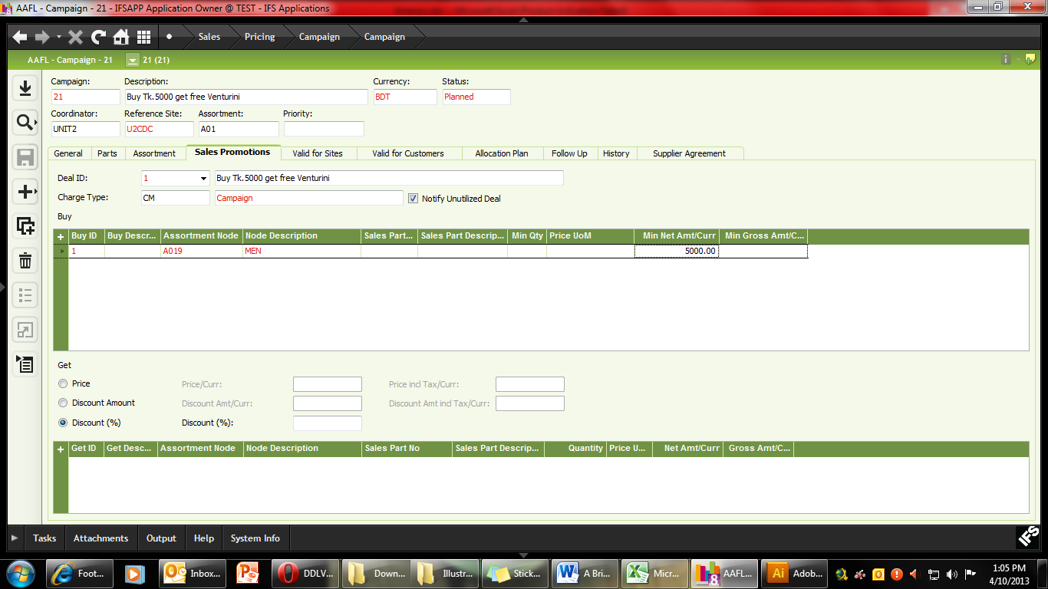
- Click SAVE.
- Now going back to the Retail Assortment (A01), navigate to the children’s article 41580A19 and copy its NODE ID information.
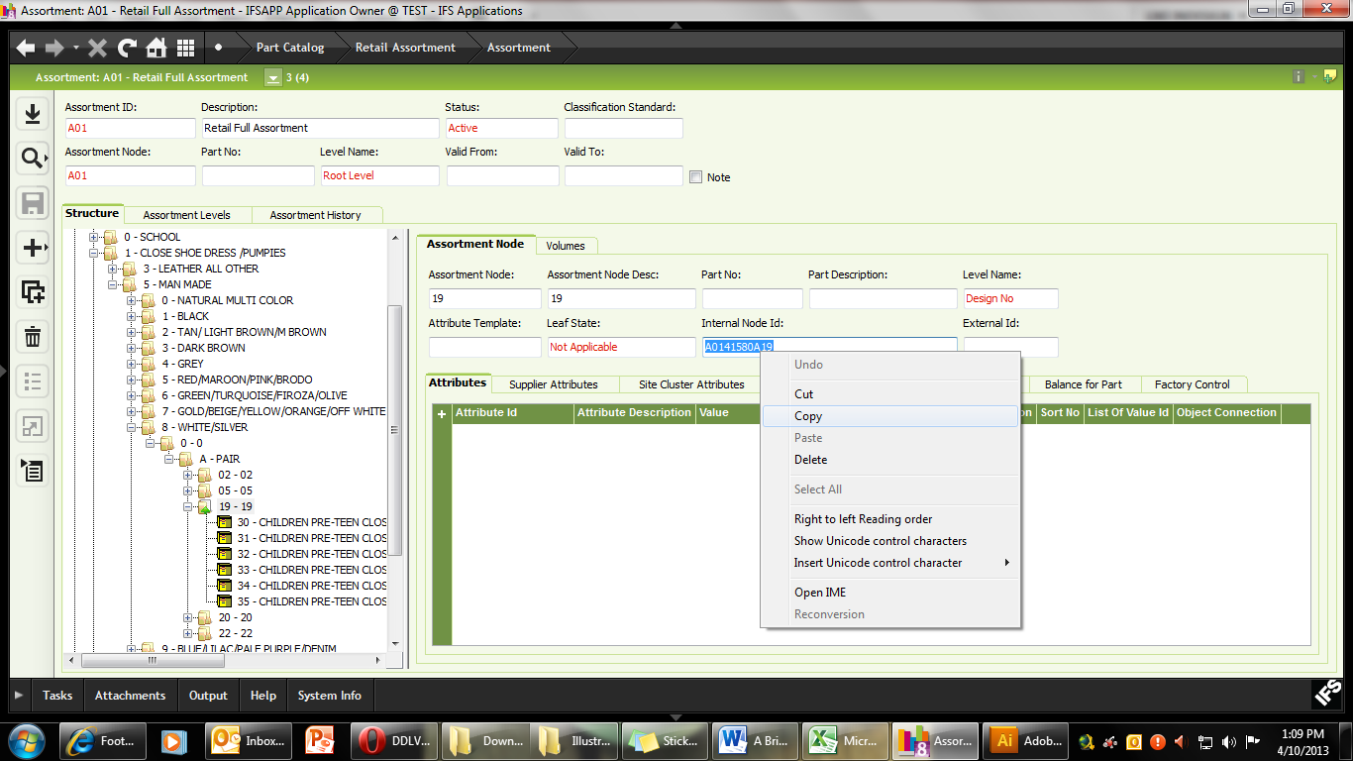
- Going back to the Campaign Module and under the Get Part, type in the Discount amount as 100
- Now use the “+” sign to add the children’s article in the Get Part Window and include the QTY (in this case 1) and the UoM (Unit of measure) as “prs” from the LOV.
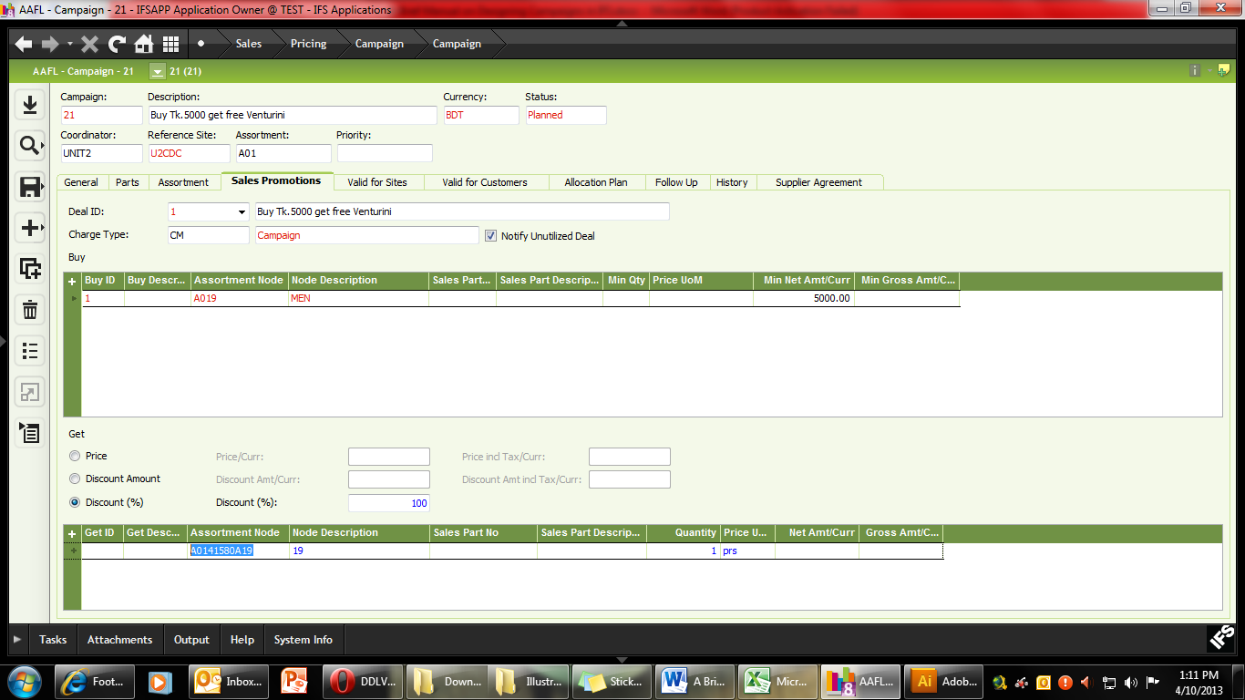
- SAVE the file.
- Now under “Valid for Sites” we can enter Dhaka Depot as the Campaign location.
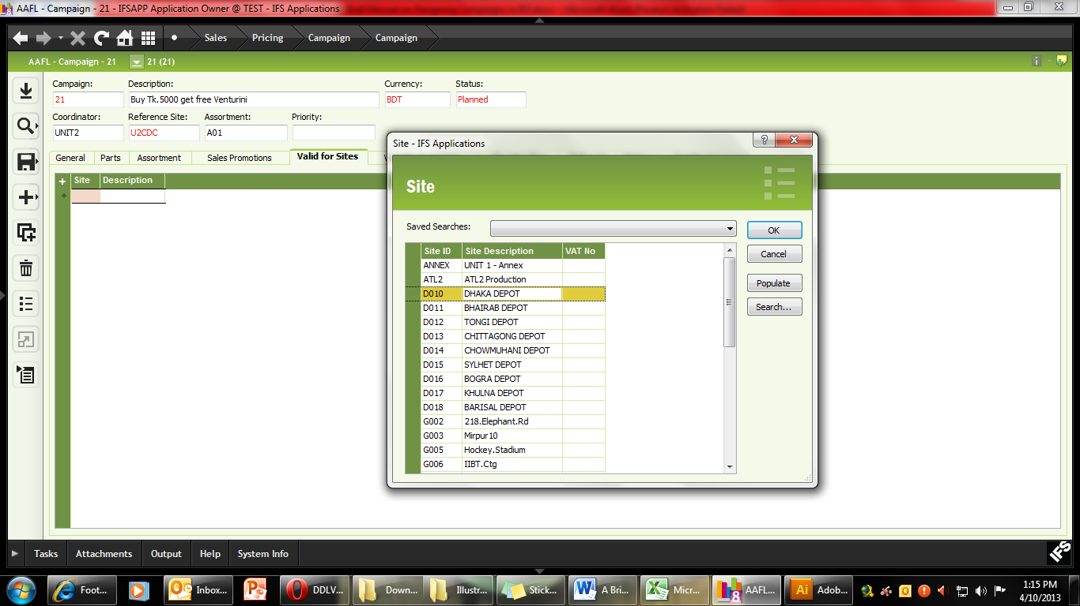
- Use the “Valid for Customers” tab ensure that the “Valid for All Customers” is ticked.
- Check to ensure that all the data entered in the campaign is correct and SAVE the Campaign.
- Finally use RMB to Activate the Campaign (or send to POS, if it is a Retail campaign).
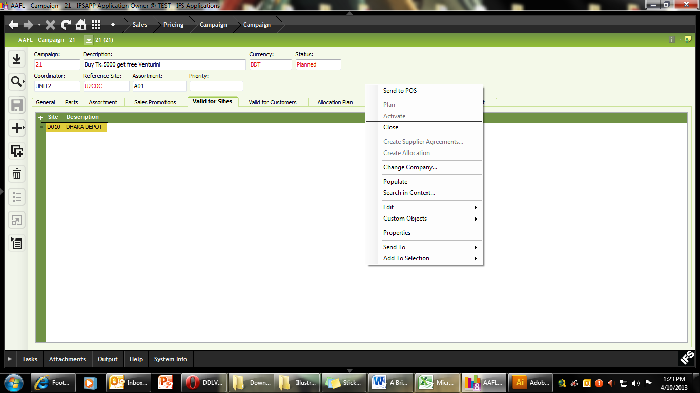
C. Lower Price of Articles for a Campaign
In this campaign we will use a slow moving article 91111A85 (sizes 39-44) and give a special price reduction from Tk. 2900 to Tk.2000 for a period of one month (Please note the article and . This campaign will be valid for Dhaka Depot and Bhairab Depot only. This same campaign can be run will multiple items. Please note however that all discounts will have to be approved by the respective authorities. In addition, for each article, all available sizes will have to be included individually within the campaign. For Price Campaigns, Retail Assortment Nodes cannot be used. This type of campaigns can also be used for institutional sales under the Wholesale wing as well.
Campaign Module Path: Sales > Pricing > Campaign
- F5 or select NEW.
- Type in campaign description (max 50 characters).
- Put in your coordinator name (if it is already not shown).
- Reference site will be U2CDC (can be typed or selected from the LOV).
- When using Price discount for specific articles only, there is no need to define the Retail Assortment. Keep field blank.
- Double Click on the Sales Start Date and use the Calendar to select the start date of your campaign.
- Double click on the Sales End Date to select the end date of your campaign.
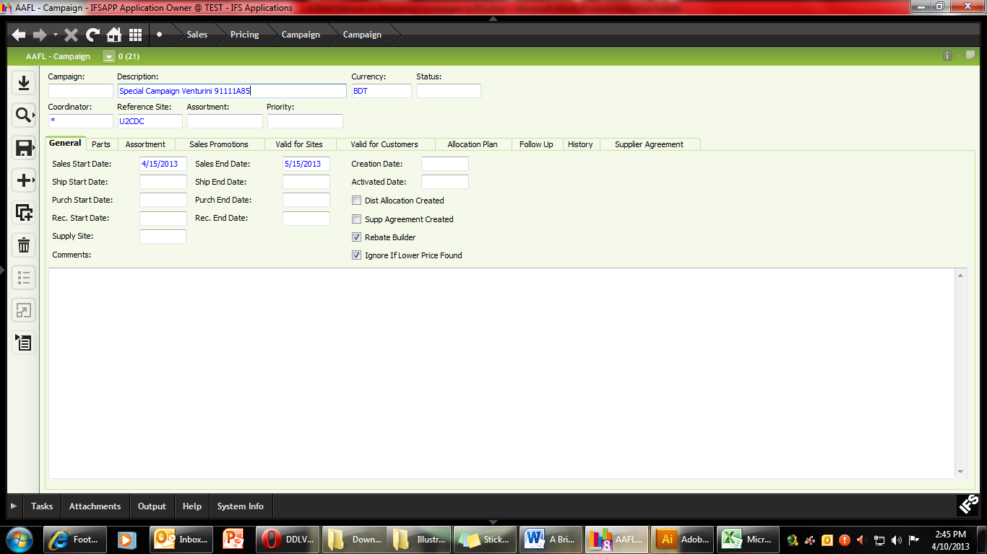
- Using the “Parts” tab, you can now enter all the relevant articles which will be offered at a reduced price, according to size.
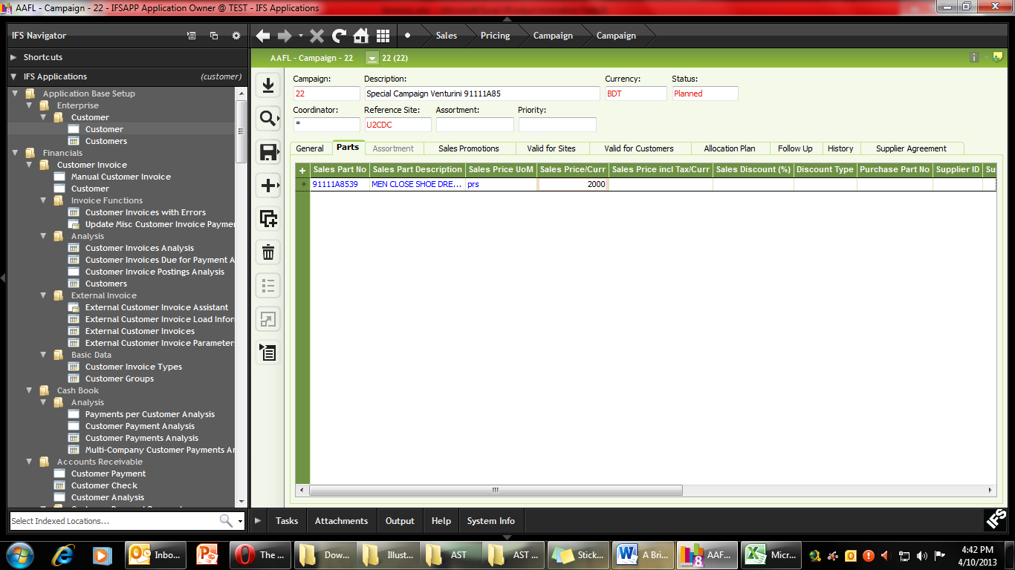
- Put the article code in the “Sales Part No” along with the size (i.e. 91111A8539). Enter the Sales Price /Curr. The price will be the discounted (or Campaign) price of the article.
When the new price is sent to POS, it will calculate the Percentage and set the price accordingly.
- Using the duplicate function, you can quickly enter all the sizes for an article, by simply changing the last 2 digits of the Sales Part number.
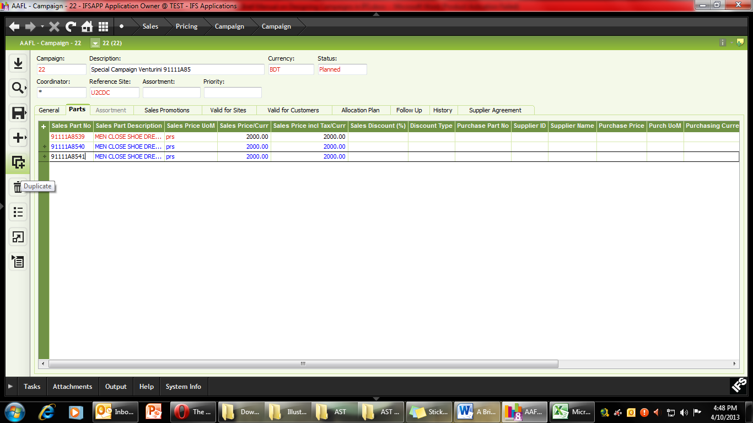
- Once all the articles needed in the Campaign has been entered, SAVE.
- Use the Valid for Sites tab to include the relevant Depots / Galleries into the campaign and SAVE. In this campaign we have entered Dhaka and Bhairab Depots.
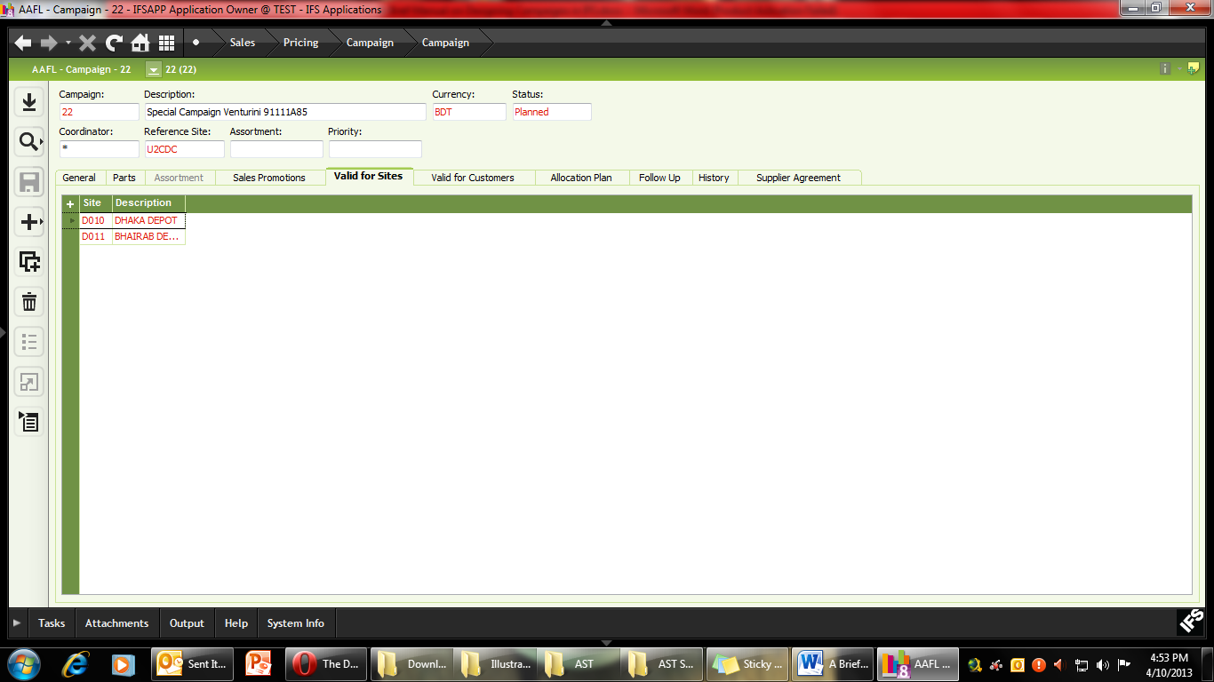
- In the Valid for Customers, it is possible to limit any Campaign to any number of selected customers. In this campaign we have selected one Dealer, Hasan Omer Shoes. If you wish this campaign to be available to all dealers, simply leave this field blank.
- Click the “+” sign to add specific customers to the Campaign.
- Select the empty “Customer” field and select LOV.
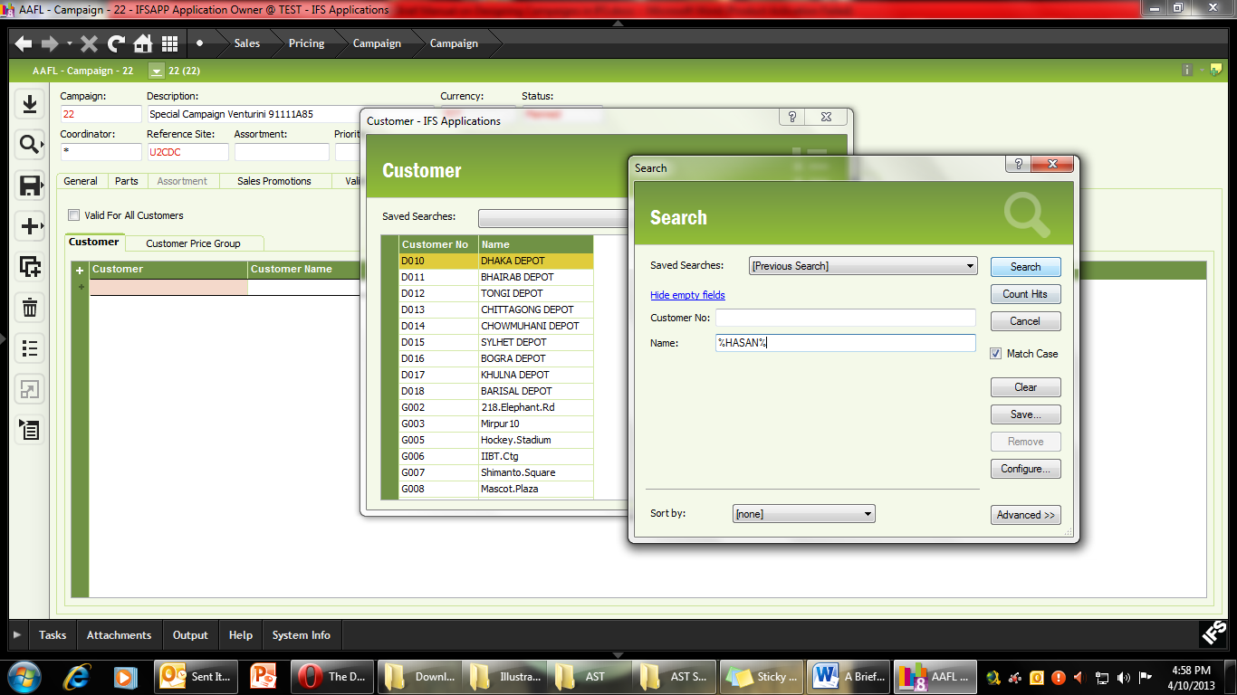
- Use the “Search” function with the string %HASAN% and once the right dealer is selected, press “OK”.
- Once all the dealers / appropriate customers have been entered SAVE the campaign.
- Check all our information once more, before using RMB to activate the Campaign.
- Please note that if this is a Retail Campaign, then you will have use RMB and choose “Send to POS” instead of “Activate”.
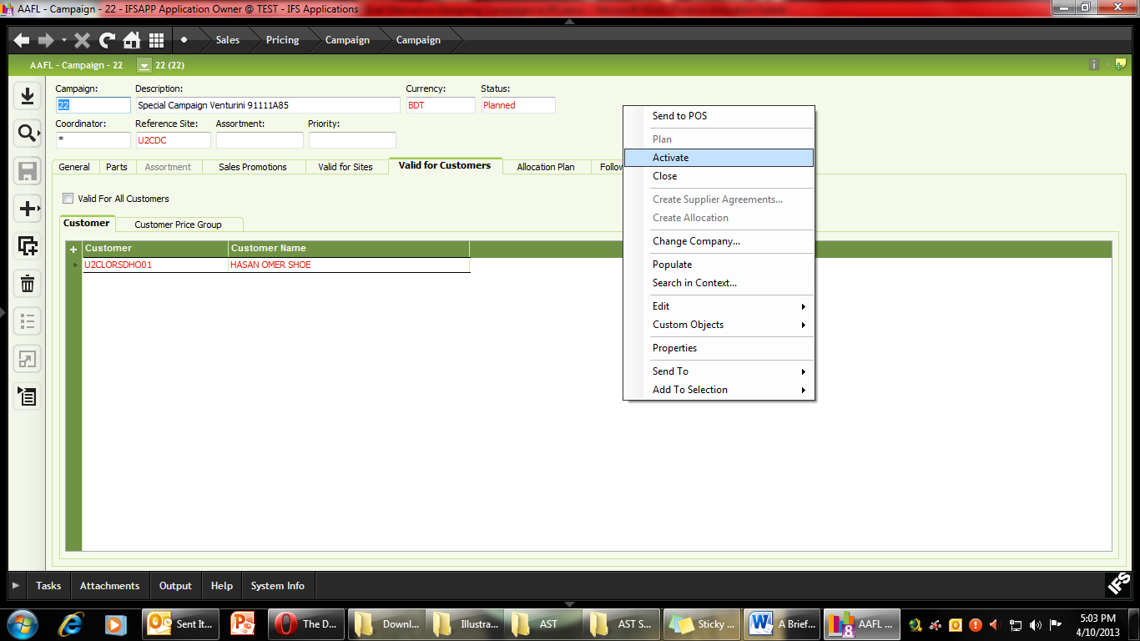

D. Give Discounts to Specific Customers – E.g. Loyal Customers
In order to give discounts to Loyal Customers, they first have to be defined using the Customer Creation Module. Any new customer has to be approved from Finance, before they are eligible for any discounts or special offers. The Discount percentage can be changed at any time for any group of customers as well. Before entering a customer, please make sure that you have all the necessary information such as the customer’s name, phone number, email, address and the approved rate of discount.
To find a specific customer group please use the search function (F3) with a specific group code. E.g. to find all loyal customers, use %LOYL% in the customer field and search.
Customer Module Path: Application Base Setup > Enterprise > Customer > Customer
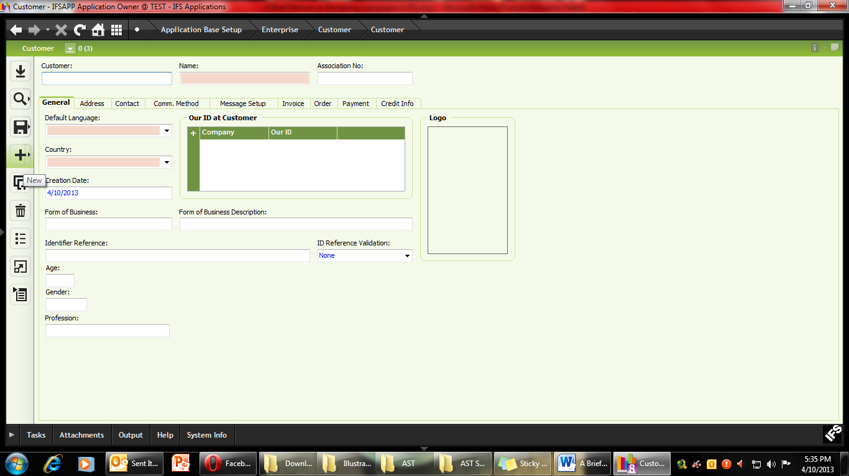
- F5 or select NEW and create the Customer Code. Please follow the Customer Coding Structure as explained in the Loyal Customers Policy. For Loyal Customers it will be U2LOYL000000.
- Type in customer’s name (Leave the Association No field empty).
- Select the Default Language as English
- Keep the Default country as Bangladesh and SAVE the file.
- Input the Age, Gender and Profession of the Customer and SAVE the file
- Go to the “Address Tab” and select “Address ID” and click New.
- Enter the Address ID as “1”.
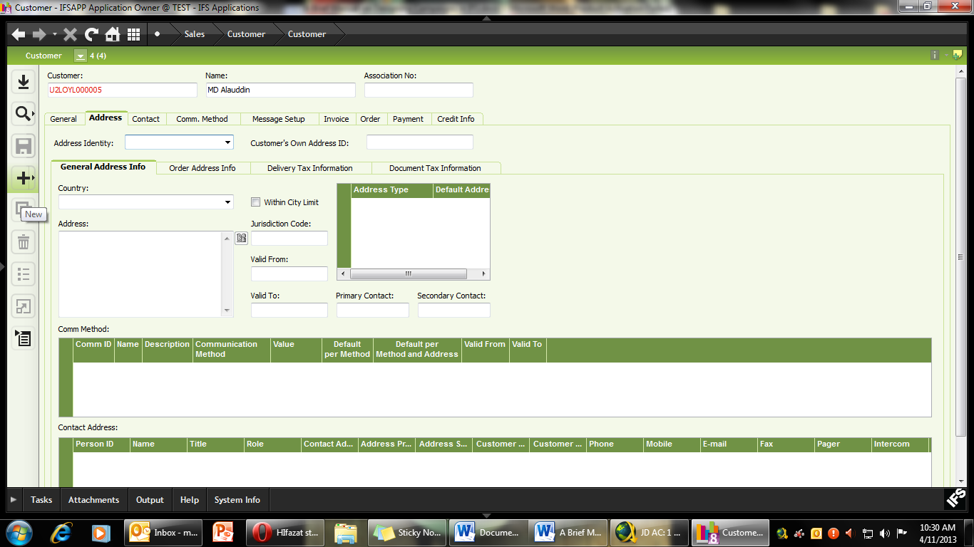
- A new Address field will be created. Using the “Edit Address” button, enter all relevant address details keeping in mind the maximum String length.
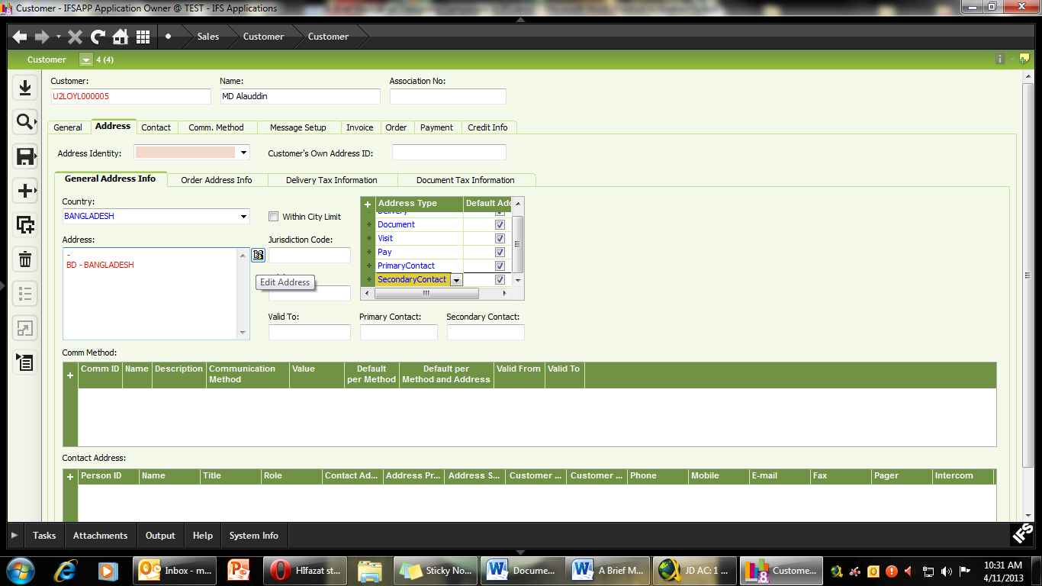
- Enter all the relevant address details and press okay. You will see that the address field is updated.
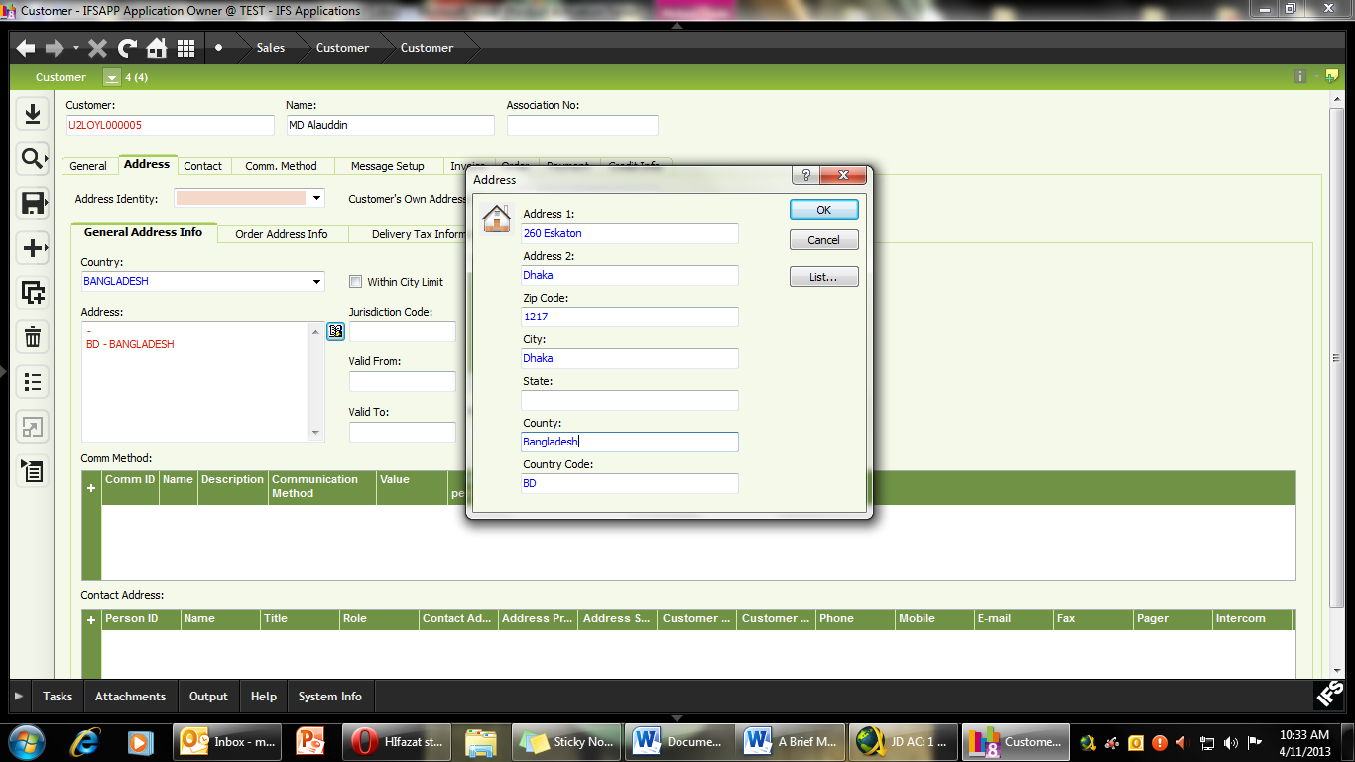
- SAVE the file.
- To add the customer’s phone number use the middle window “Comm Method”. Click the “+” sign and enter the customer’s phone number.
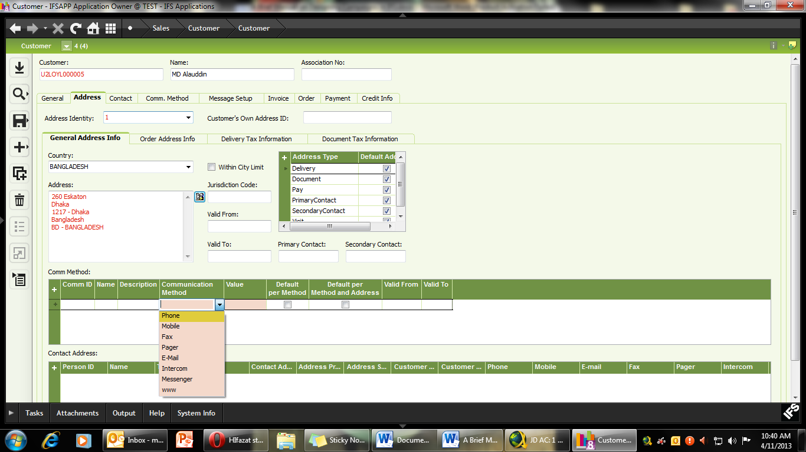
- From the drop down menu, select Phone and then enter the number in the next box.
- SAVE the file.
- Now we can define the Customer Type and Payment terms using the Invoice tab (and then the General Tab).
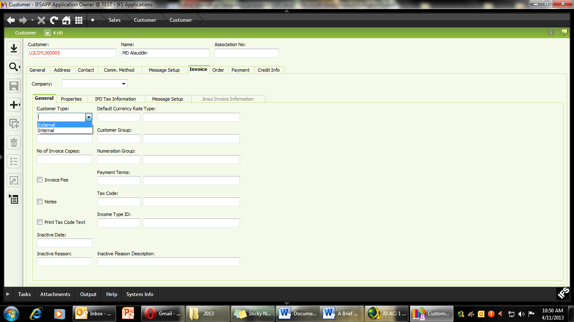
- Select the Company field and click New. The Company will be automatically be shown as AAFL.
- Select the customer type as External. All employees under the Manzur Elahi Enterprise banner will be considered as internal employees.
- Under Customer Group use the LOV to select the customer group appropriate for you and press “OK”. For Retail Customers it should be U2GAL, For Wholesale U2WSD /U2RSD or U2ISC (for institutional customers).
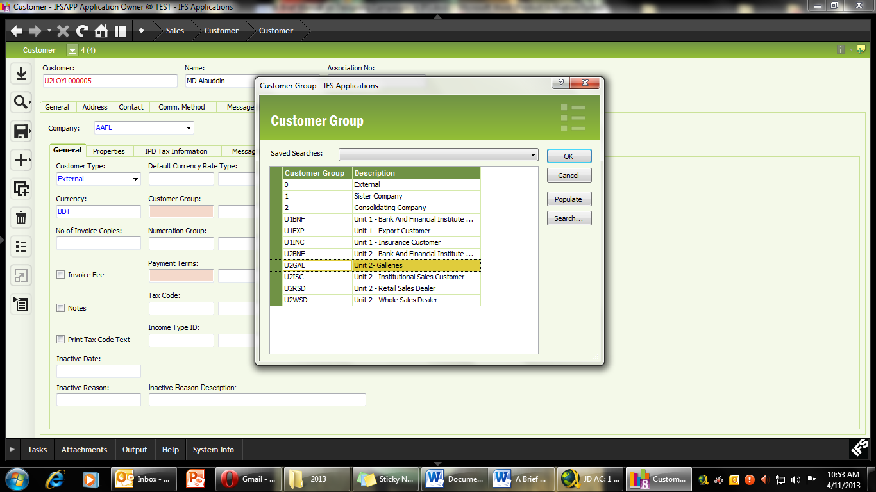
- In the payment term, based on Finance’s recommendation, select the appropriate option using LOV. In this example we have chosen the option U2D000 – indicating its Unit 2, Pay immediately.
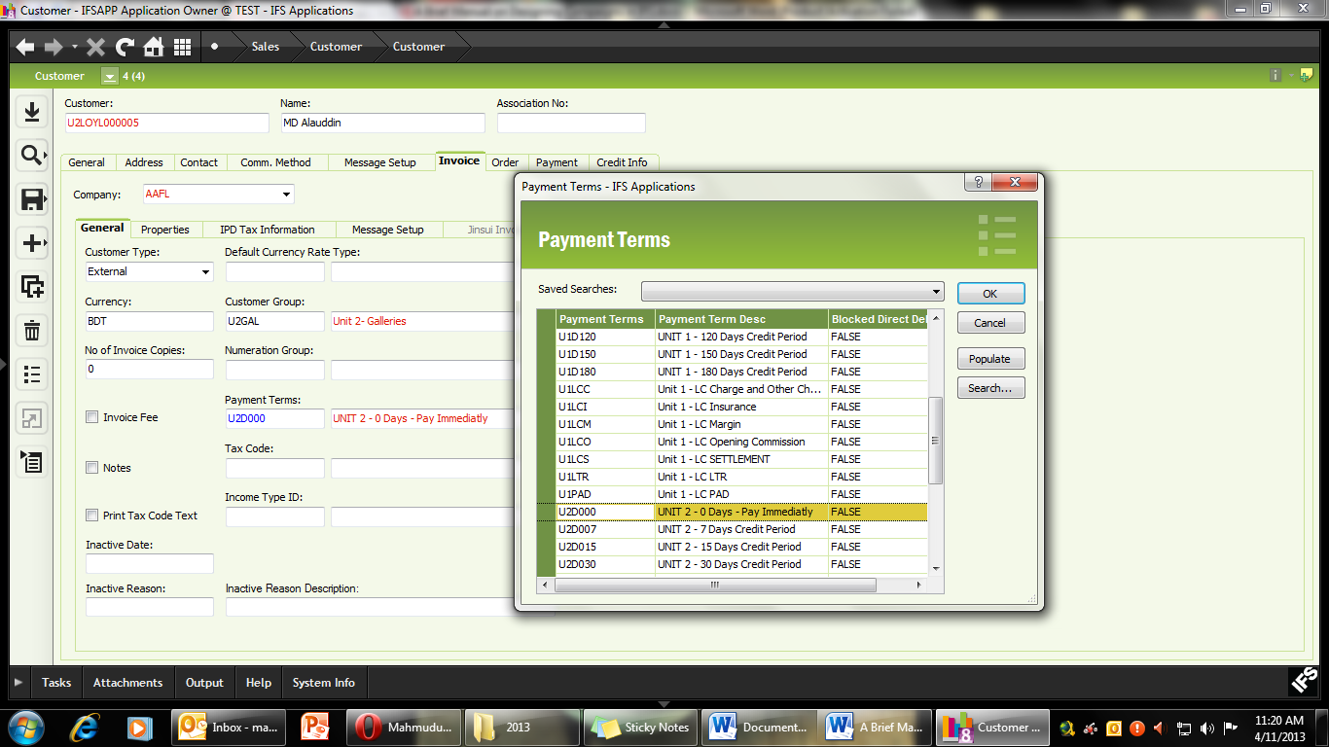
- SAVE the file.
- Now we can define the Discount type using the “Order” tab.
- Select the “Customer Stat Group” and select New.
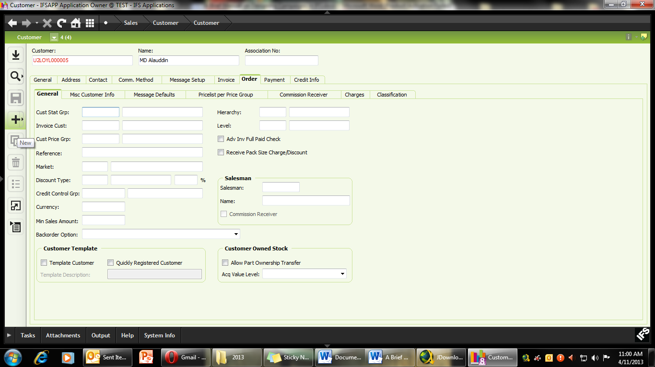
- In the Customer Stat Group field, use LOV. In this example we are using LOYL01.
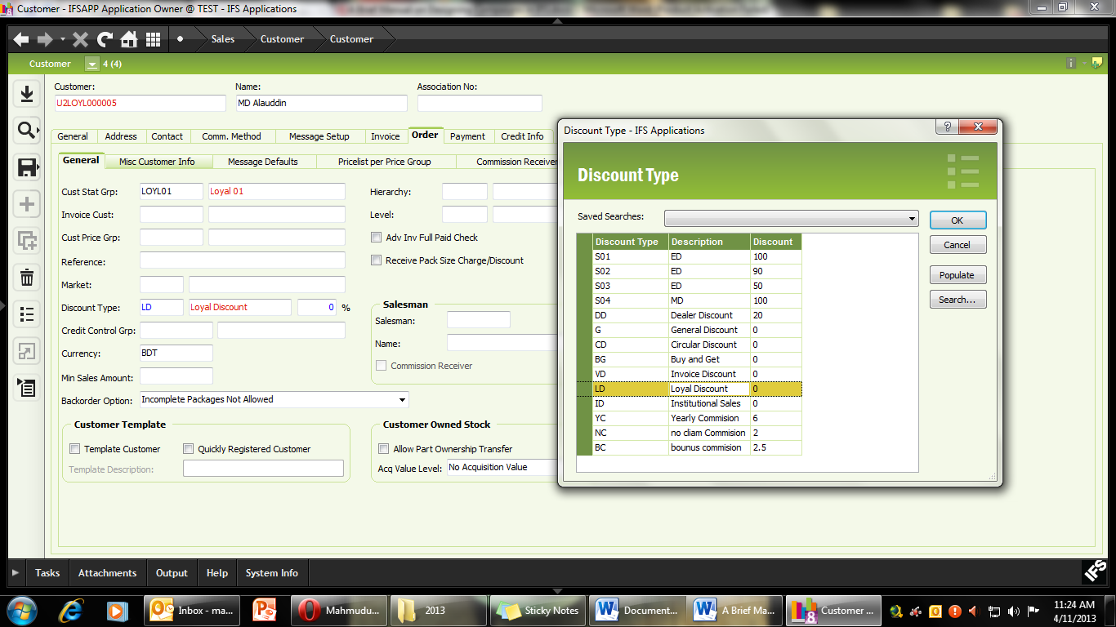
- Using the LOV set the currency as BDT and SAVE the file
- In the Discount Type use LOV to select appropriate Discount Category and click “OK”. In this example we are using LD (as in Loyal Discount).
- Enter the approved Discount Percentage and save the file.
- Finally, we will define the Payment type using the “Payment” tab.
- Select the “Company” field and press “New”.
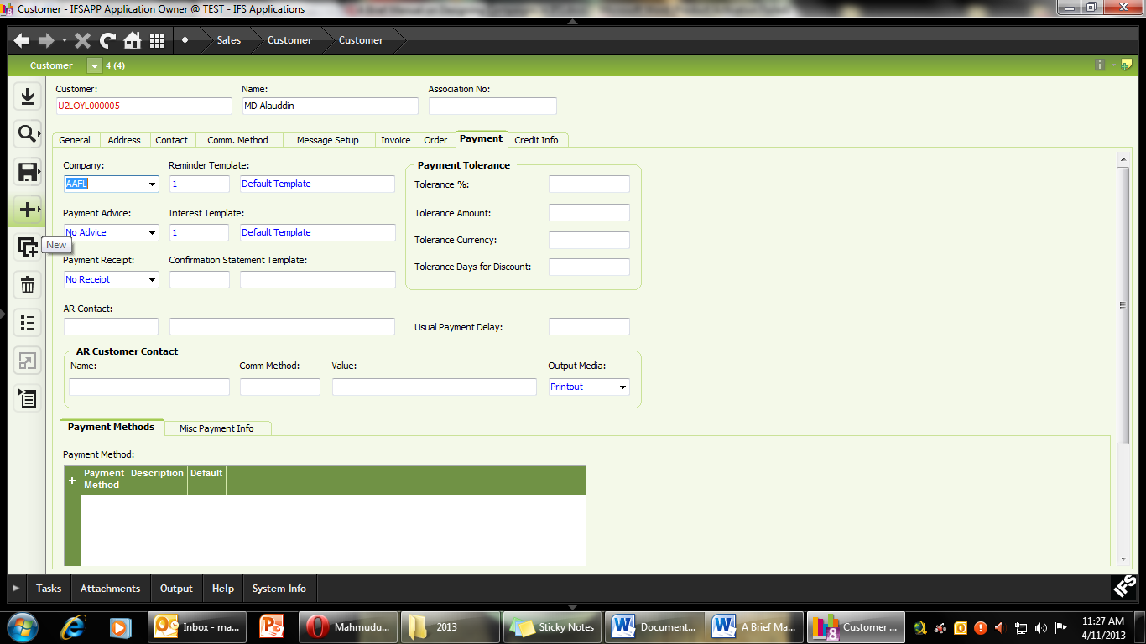
- Most of the fields will be automatically updated. SAVE the file.
- Re-check all the data that has been entered.
- Since this is a Loyal Customer for Retail, RMB and click “Send to POS”.
E. Issuing Gift Vouchers for Institutional Customers
In this campaign AAFL will provide 200 vouchers to Dhaka Bank for 10% discount on its women’s article 82560A01. In his campaign each voucher, a customer can only purchase 1 pair of shoes. The voucher will only be valid for Bashundhara City and 218 Elephant Road outlets.
Gift Vouchers is currently available for Retail Galleries only. These vouchers are issued for a specific organization for fixed time, at a fixed rate of discount. Based on the agreement with the customer, these vouchers can apply to specific articles (all sizes), or all regular priced articles. Additionally, the number of Galleries from where these vouchers will be accepted is also fixed. Each voucher has a code number. E.g. For Dhaka Bank it will be DBL0001, DBL0002 etc. Before issuing any gift vouchers for a customer, the customer’s (or the company’s) data must be entered and verified by Finance. For details on Institutional customer policy, refer to Appendix 3 (for Retail).
Campaign Module Path: Sales > Pricing > Customer Agreement > Customer Agreement
- Select the “Customer Agreement” field and click New.
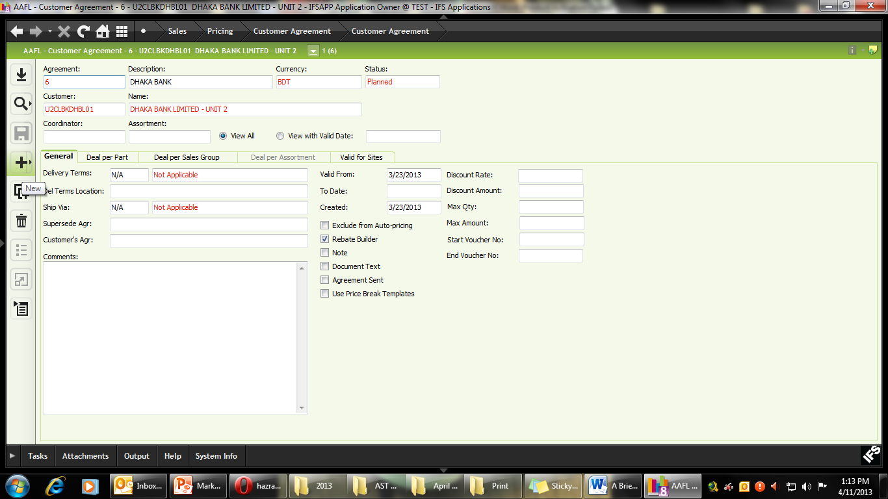
- Type in the description of the agreement (max 50 characters).
- Using LOV, select the currency as BDT
- In the Customer field, use LOV to search for the appropriate customer. In this example, we are looking for Dhaka Bank, hence the search string is %BANK%.
Please ensure that the customer you are searching for has already been entered into the customer database by Finance.
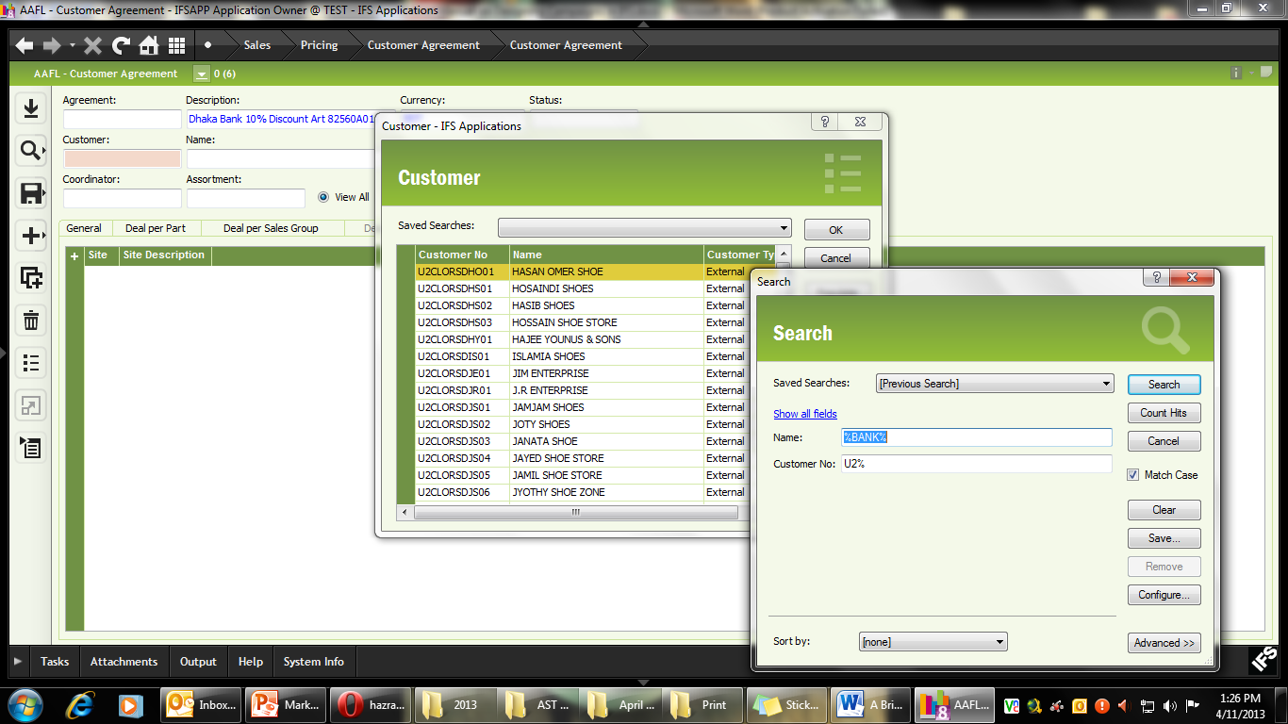
- Once you have found the right Customer, click “OK”
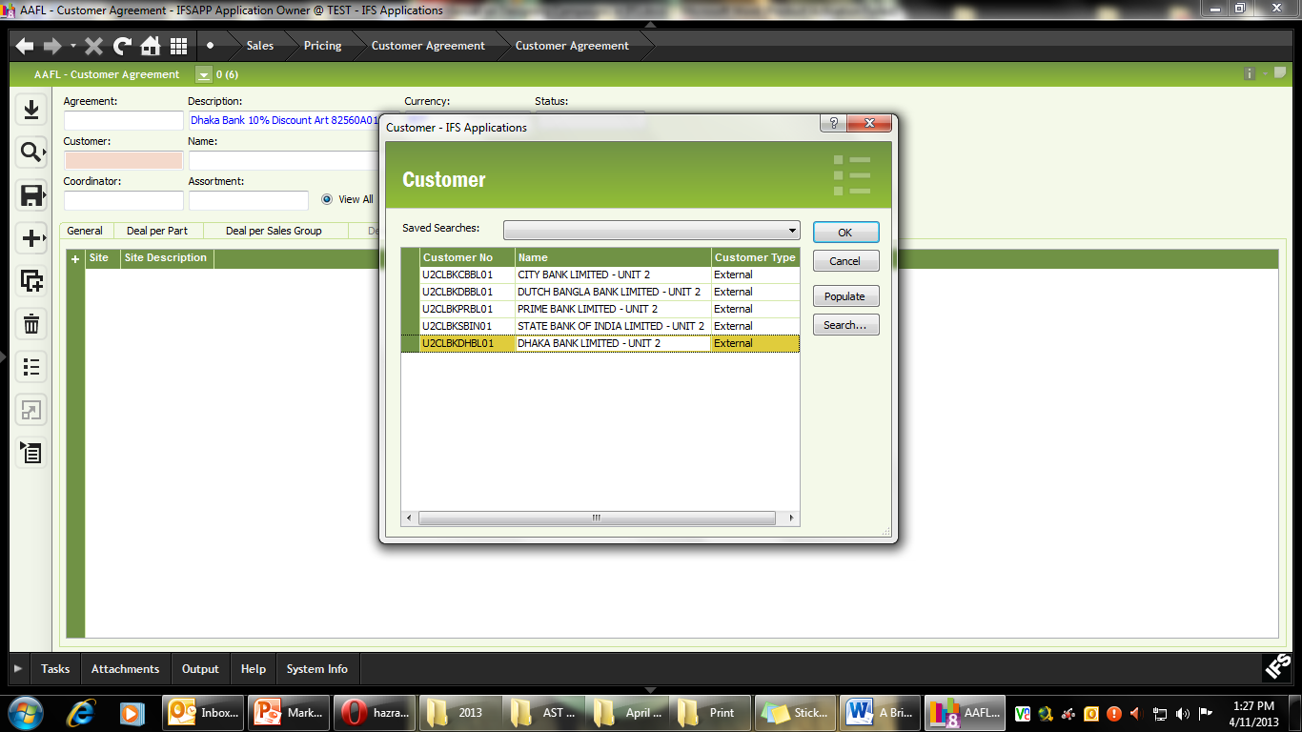
- SAVE the file. Please note that the agreement ID has been auto generated by IFS.
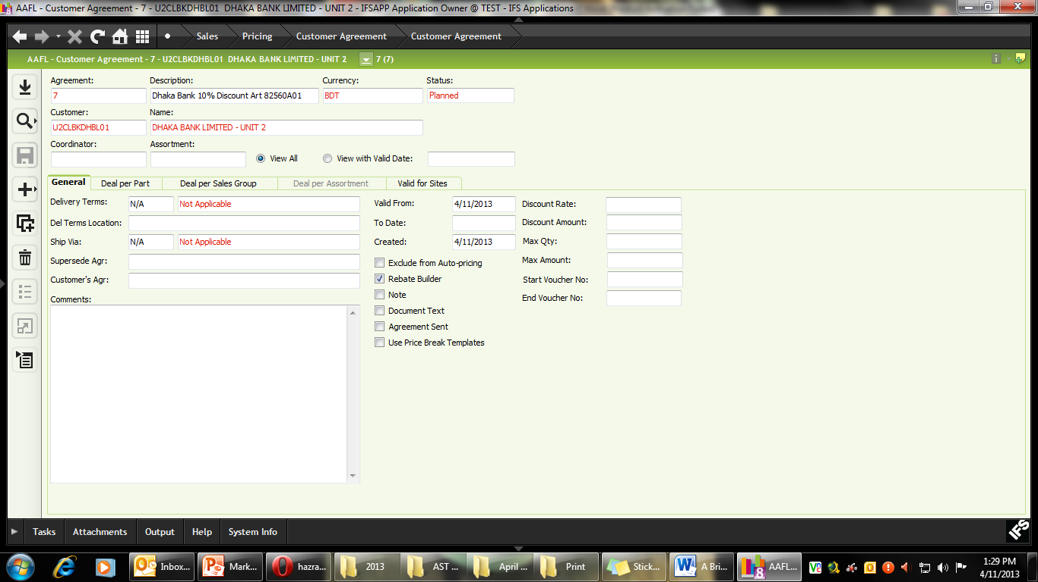
- In the “General” tab, tick the “Rebate Builder” option.
- In the “Valid from” field, enter the start date of the campaign (or the date from which the voucher will be valid).
- “To Date” enter the date up to which the voucher will be valid (the maximum time limited of the voucher). No voucher can be redeemed before or after the campaign date.
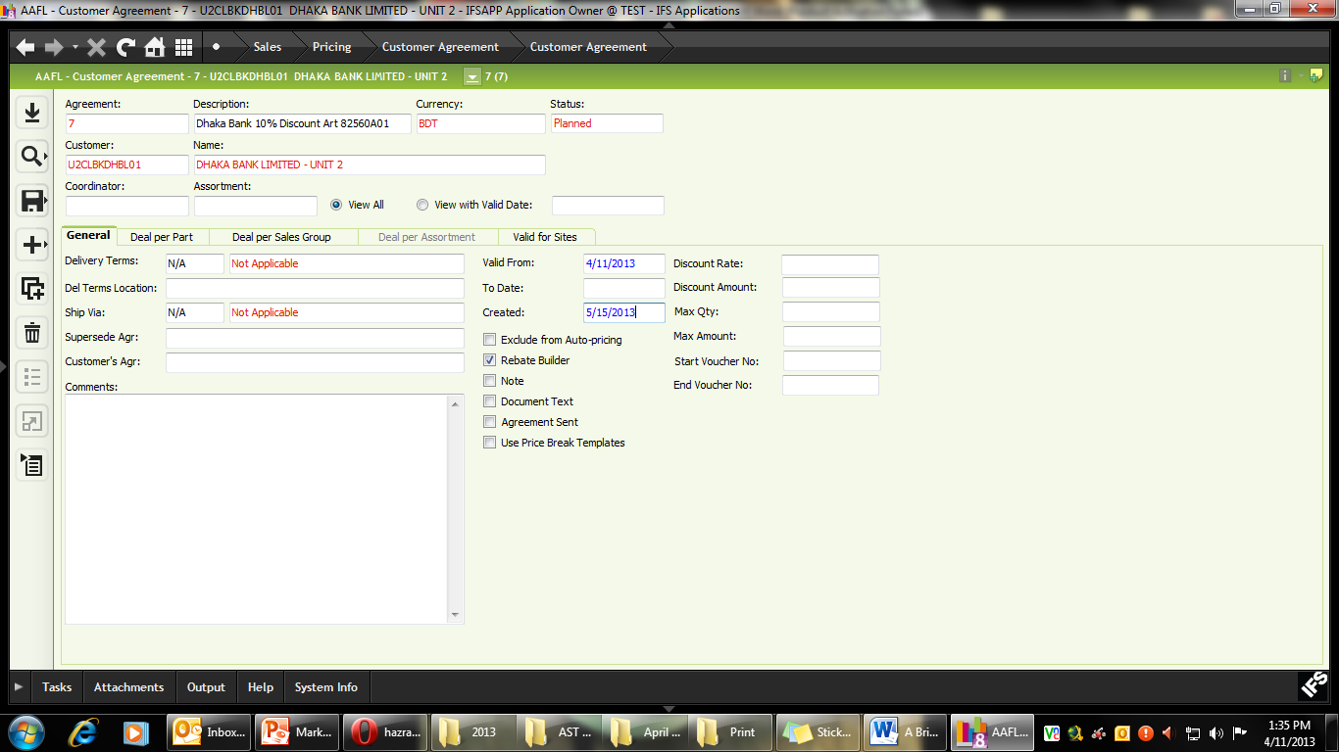
- In the “Discount Rate” field enter 10 (as in 10% discount). It is also possible to use “Discount Amount” instead of Discount Rate. E.g. for a Gift Voucher of BDT 500. However, it is critical that Discount Rate and Discount Amount are not used together for the same campaign.
- When issuing percentage discount vouchers, it is important to define how many pairs or pieces of products can be purchased with each voucher. In this campaign we will set “Max Qty” to 1.
- In the “Start Voucher No” enter DBL0001. In the “End Voucher No” enter BDL0200 (as we are issuing 200 vouchers).
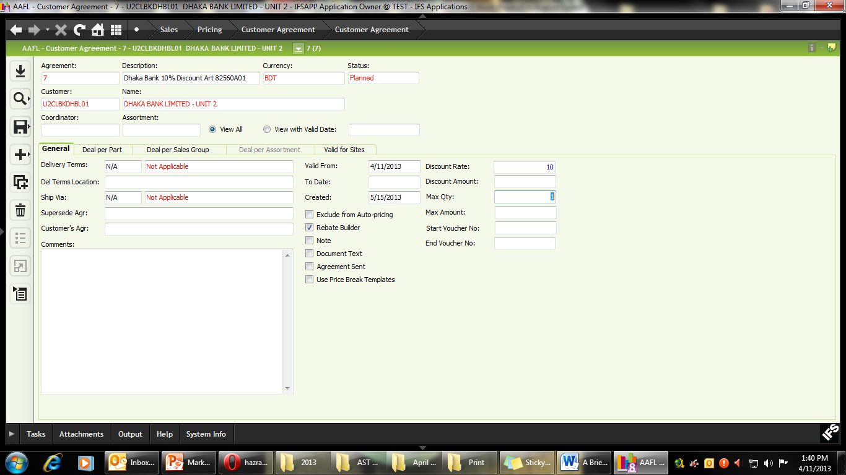
- SAVE the File
- We can now use the “Deal per Part” tab to assign specific articles (size wise) which can be purchased using the Gift Vouchers.
- Click the “+” sign and enter the article code along with size in the “Sales Part” field.
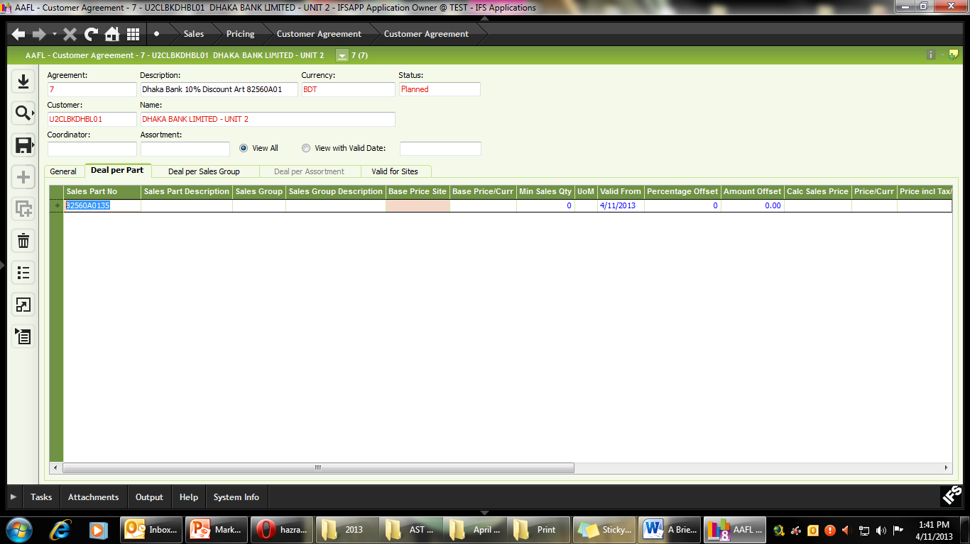
- SAVE THE FILE. Please note that the Base Price and Site are automatically updated by IFS.
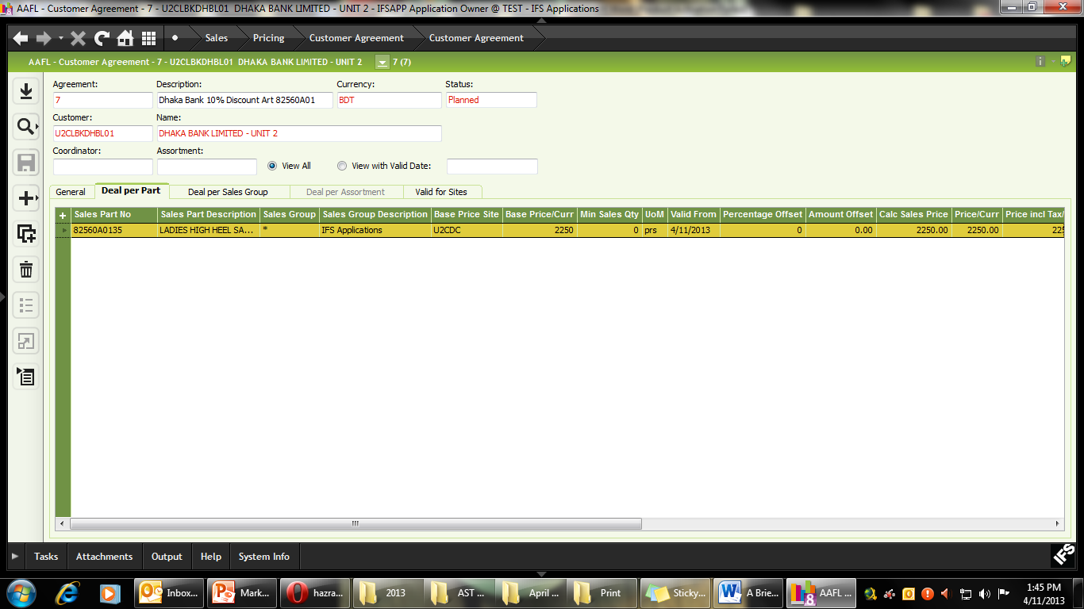
- Select the article and use the “Duplicate” function to include all the relevant sizes of the article and just change the last two digits (i.e. size) in each sales part. Remember to SAVE the file, each time after adding a new size before duplicating it.
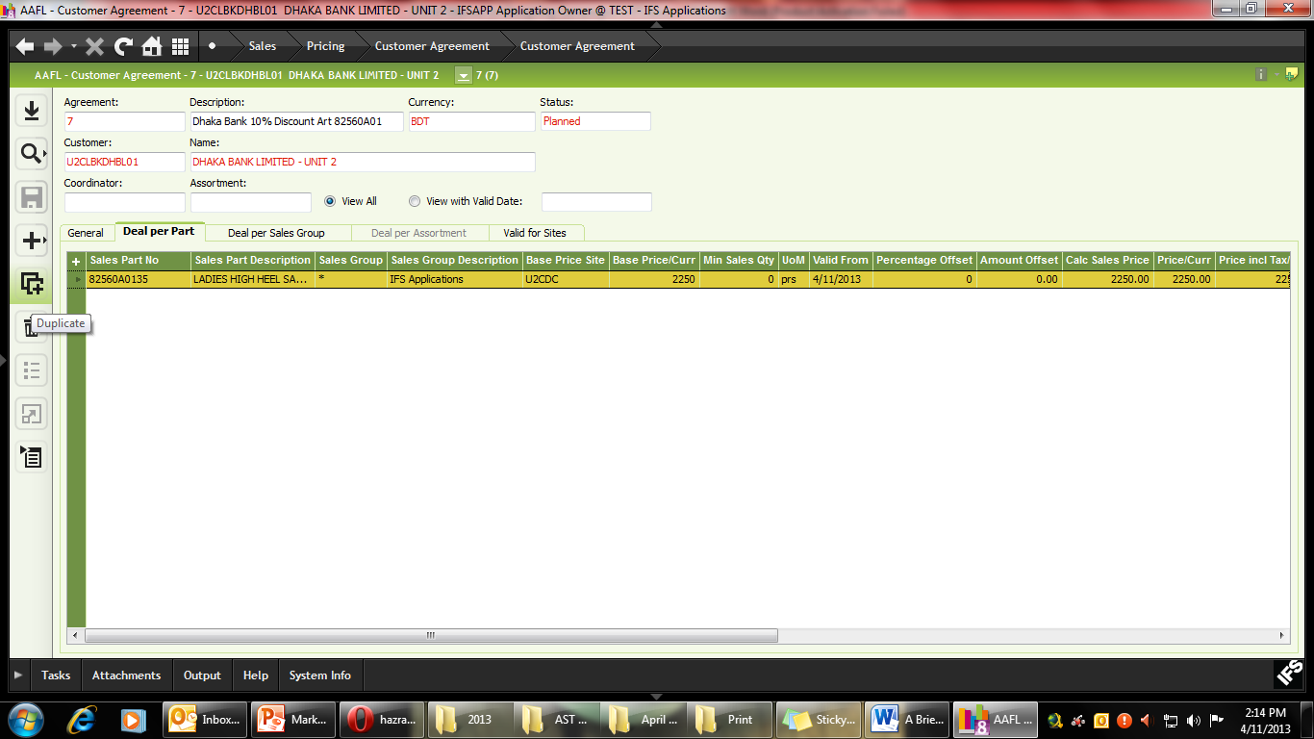
- Once all the articles (along with size) has been added to the Parts list, SAVE the file.
- In the “Valid for Sites” tab include the selected Galleries by using the “+” sign and the LOV.
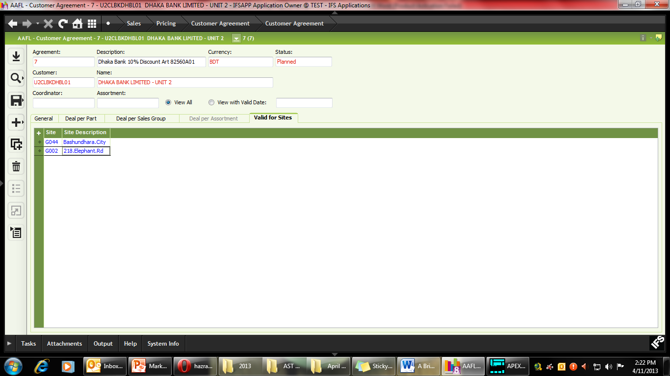
- SAVE the file
- Check all the relevant data once more.
- RMB and Send to POS.
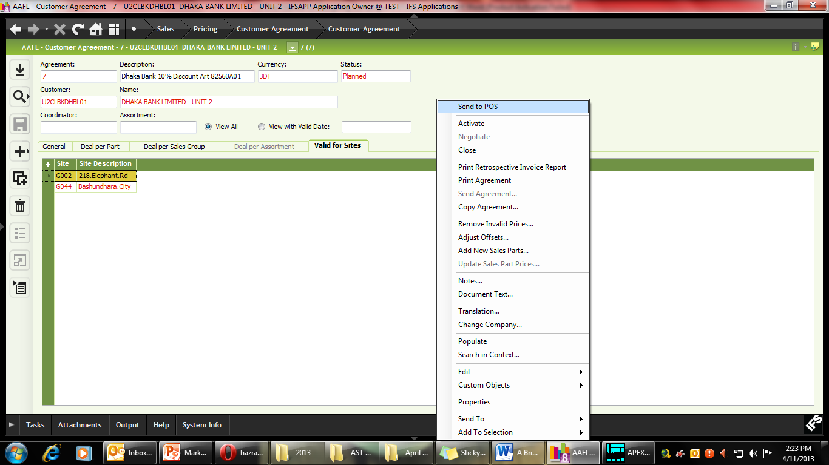
- You will receive a message saying Operation has been performed successfully.
Please note that for POS related campaigns, you do not need to activate it from IFS. You will however, need to “Activate” it if you are designing campaigns for Depots running IFS.
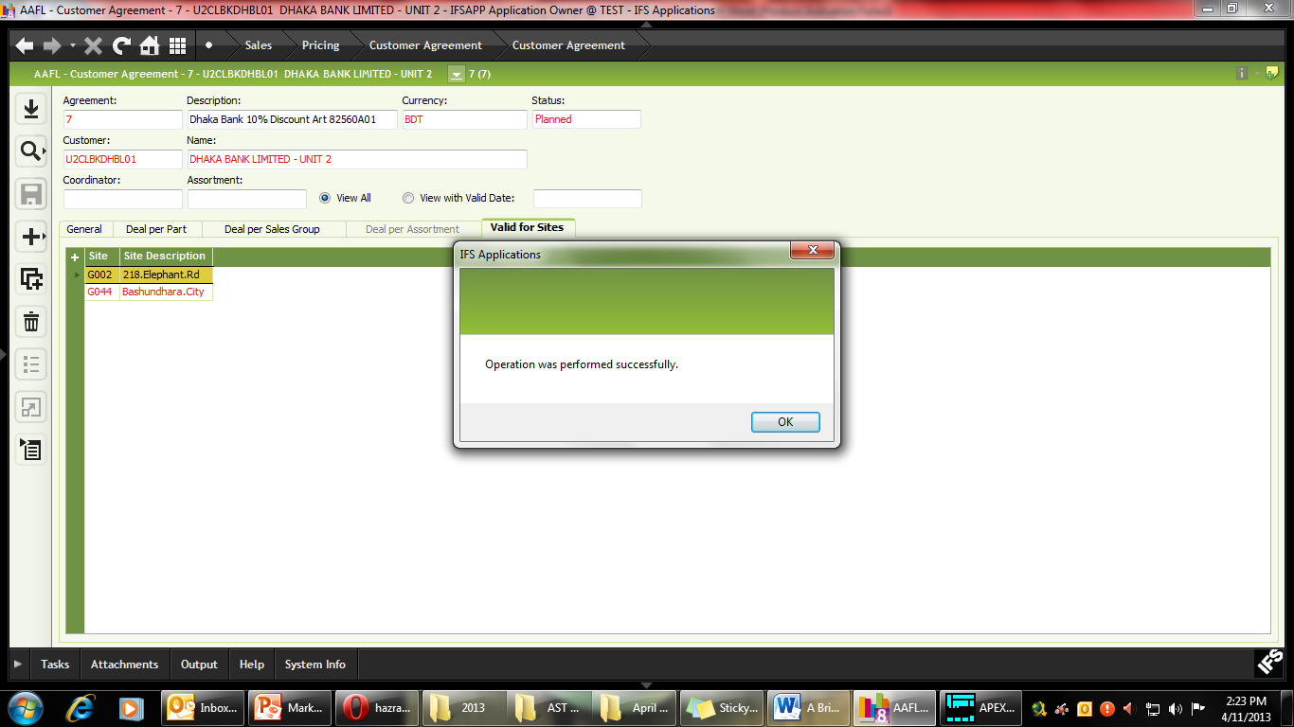

F. Using Price Lists for Institutional Customers under Wholesale
In this campaign we will be supplying 500 pairs of Article 91111A85 to City Bank at 20% discount. The campaign will be run from the Dhaka Depot and valid between 11 April 2013 and 15 May 2013.
Campaign Module Path: Sales > Pricing > Customer Agreement > Customer Agreement
- Select the “Customer Agreement” field and click New.
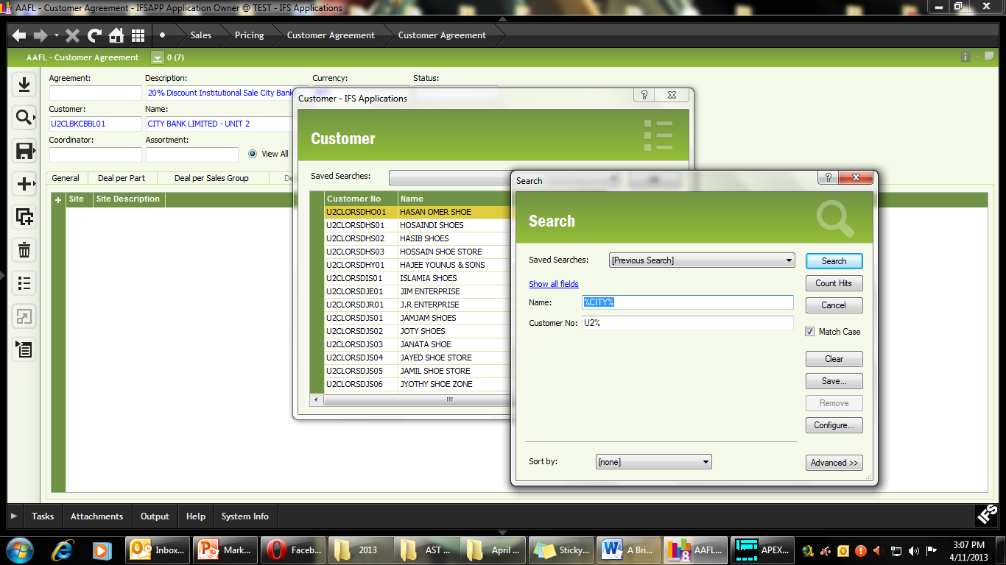
- Type in the description of the agreement (max 50 characters).
- Using LOV, select the currency as BDT
- In the Customer field, use LOV to search for the appropriate customer. In this example, we are looking for City Bank, hence the search string is %Bank% and Customer No %U2%
Please ensure that the customer you are searching for has already been entered into the customer database by Finance.
- Set the Campaign validity using Valid To and Valid from Date. In this campaign we are setting date between April 11 and May 15, 2013.
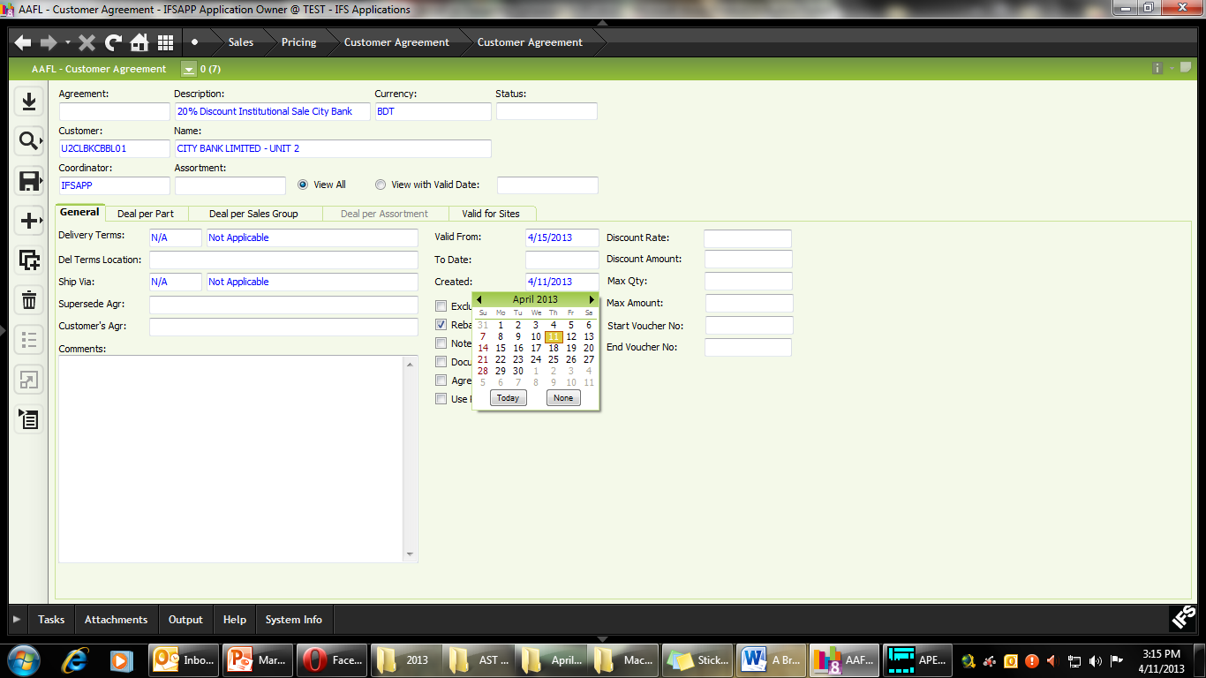
- SAVE the Campaign
- Using the “Deal per Part” tab, select all the relevant articles included in the campaign according to size using the “+” sign and entering the Sales part number with size. In this campaign we will add Article 91111A8539 to 91111A8544 (i.e. size 39 to 44).
- In the “Percentage Offset” field enter -20. This indicates that the selected item will be sold at 20% discount to City Bank.
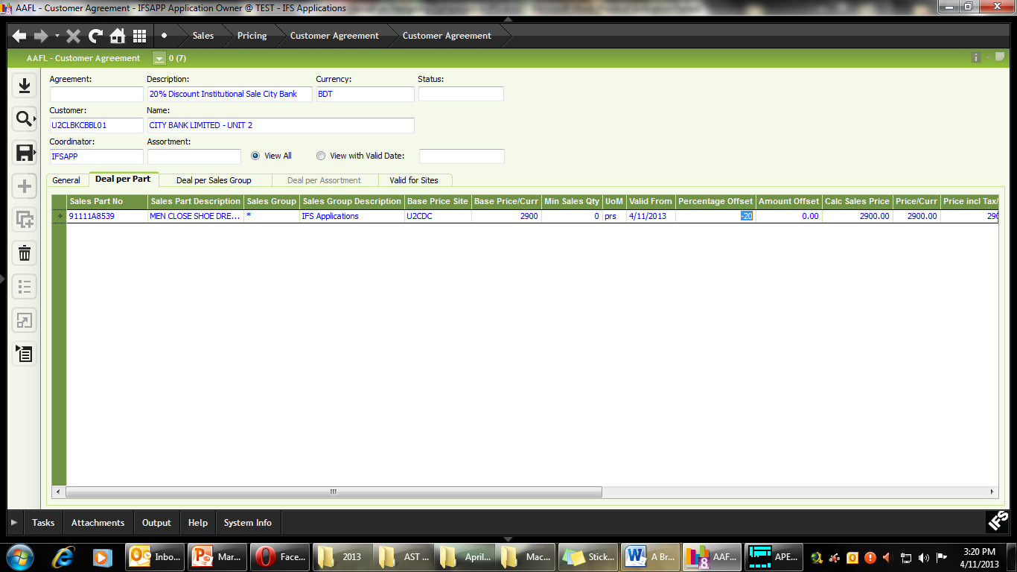
- SAVE the file.
- Use the Duplicate function to quickly add all relevant sizes (changing the last 2 digits for size). After duplicating each size, make sure you save the file before duplicating the next one.
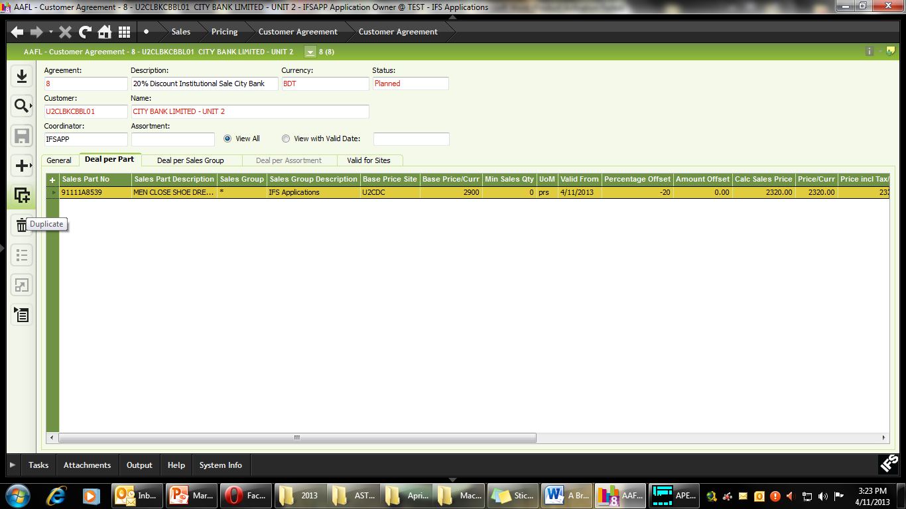
- Use the “Valid for sites” tab to enter the relevant depots to the campaign. In this example, this will be Dhaka Depot (D010).
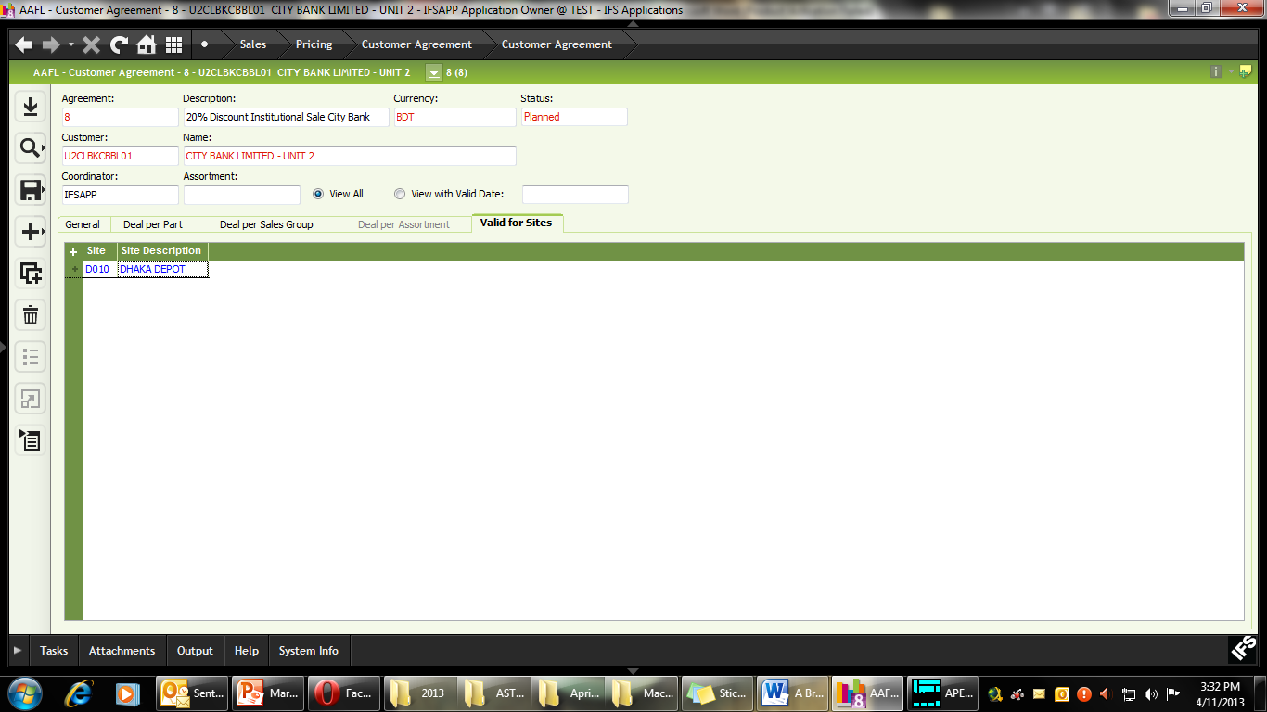
- SAVE the campaign.
- Check all data that has been entered.
- After all necessary data has been entered, use RMB and “Activate” the Campaign.
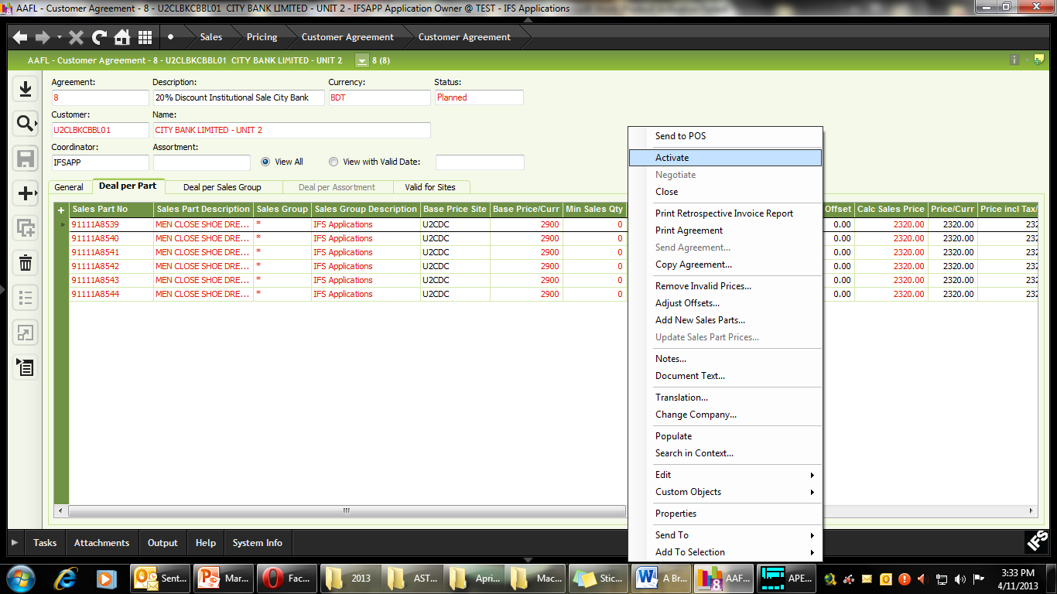
- You will see that the Campaign Status has changed from Planned to Active.

G. Appendices
1. BUY and Get and Invoice Amount (Sales Offer) Campaign Policy
What is Sales Offer?
This is an offer to Retail customers of Gallerie Apex, where by purchasing a minimum quantity of an article, he or she will be eligible to receive another specific article free of charge or at a specified rate of discount. The offer can also be based on value of purchase (instead of quantity). E.g. anyone who purchases over BDT 5,000 will receive a shoe-shiner free of charge.
What are the characteristics of Discount Coupons under Corporate Sales?
1. The sales offer will be given for specific articles (e.g. slow movers).
2. The offer will be valid for a particular range of sites (or site clusters).
3. The offer will be valid for a specific period of time (e.g. From March 1 to March 30, 2013).
4. The offer may be applicable for multiple items, which when purchased together, will allow a customer to receive another item free of charge or at specified rate of discount.
5. The offer may also be applicable for a specific amount of purchases. By purchasing products worth a given amount of BDT, the customer can receive one of the selected complimentary gifts or receive a specified discount on the item.
6. Before any Sales Offer is activated, the possible combination of items, and their accompanying rewards will be clearly specified to both Mediasoft and IFS.
7. The offer modalities will be defined in IFS Campaign module and be transferred to POS for execution.
8. The sales offer will be generated through a Circular, and this Circular number should be recorded in both IFS and Mediasoft for administrative and reporting purposes.
9. Any item sold through the Sales Offer will not be applicable for Claim. This means these articles will not fall under the standard 30 day Claim Policy offered by Gallerie Apex.
10. The Sales Offer can be valid for both Retail Sites and Depots (Wholesale) However, there can be separate campaigns for each channel.
11. At any given time, there can be multiple Sales Offers running in the Galleries. The articles for each offer, however, will be separate.
12. Buy and Get and Invoice amount campaign types will not run simultaneously.
13. The same sales part will not feature in more than one campaign at a time.
14. For Invoice Amount Campaigns, the customer’s total purchases must be equal or higher than the stipulated amount without the gift or discount item.
15. The customer may have options in regards to choosing the gift (i.e. hey may take gift A or gift B).
16. Items which are already on circular or seasonal discount will not be applicable for Buy and Get and Invoice Amount campaigns. These items will have to be entered separately in the customer invoice (at the very last).
Examples of Sales Offers
Sales Offer 1: Gallerie Apex Family Offer
By buying article 1132111 (men’s shoes) and article 2013105 (women’s sandal), you will receive article 8022102 (children’s shoe) or 8013105 (children’s sandal), free of charge.
Sales Offer 2: Gallerie Apex Big Spender Offer
Purchase BDT 5,000 or more (any articles) and receive a complimentary Shoe Shiner free of charge.
Sales Offer 3: Privilege Offer
This week, buy any Apex shoe and receive a pair of socks (article X OR article Y) free of charge.
Buy a Venturini and receive a Leather Wallet (article X) complimentary with your purchase.
Sales Offer 4: Big Saver
Buy a pair of Apex Shoes (article 91111A4039 to nth article) and Nino Rossi Sandals (6111A3638 to nth article), and get 50% discount on Apex Leather Belts (01111A0501 or 01111A0601).

What are the required mechanisms for POS
A circular will be sent to all the sites under the campaign from the head office. POS should receive Sales Offer modality from IFS and create the necessary set of instructions for the POS server. Additionally, POS will then create a notification window to inform the store manager that the customer is qualified to receive a particular gift or offer. An optional physical log book with customer’s name and signature for the campaign maybe maintained at the Gallerie for verification purposes.
2. Gallerie Apex Loyal Customer Policy
1. Core Idea
The objective is to introduce discount based reward policy for frequent customers of Gallerie Apex. Any customer who purchases BDT 3,000 worth of products from Gallerie Apex will be eligible for membership. A 10% discount card will be mailed to him/her after verification, which will be valid on all of the customer’s purchases till the end of 2013. Gallerie Apex will receive periodic updates of the customer’s purchases and purchase patterns.
2. Customer Selection Criterion
A customer loyalty form will initially be available in 22 selected outlets in Dhaka. Anyone who purchases BDT 3,000 worth of products (at one time) from these outlets will be offered the membership form. The completed forms will be sent to the head office for verification. Once verification is complete, a plastic membership card will be mailed to him or her.
Based on the experience of operating the scheme within Dhaka, 55 additional stores (countrywide) can be integrated into the scheme in the second phase. However, discount stores, WSDs and RSDs will be outside the purview of this scheme. Additionally, the scheme will exclude Lotto until further notice.
3. Modus Operandi of the Loyalty Scheme
A bar coded loyalty card (plastic) with a unique serial number will be issued to the customer. Only when this bar code is scanned will the machine allow the discount to be recorded. No manual entry will be allowed.
Using the card, the customer may obtain 10% discount on all of his/her purchases from the selected showrooms as many times as he or she wants within 2013.
The card will not apply on articles which are already on discount or items which are sold with a Sales Offer (e.g. Free socks with shoes) etc.
The card can be used by other members of the card holder’s family. If the card is lost, then the owner must submit the unique serial number along with his personal details and pay for the card replacement cost.
If a member is found to abuse his/her card, a provision must be there to cancel membership (ID) from the local POS Serer (within a day’s notice).
The marketing department requires periodic reports on the total sales (pairs and turnover) made through this scheme. Customer wise reports are also required.

3. Institutional Policy (Corporate Customers) for Retail
What is Corporate Sales?
An agreement between AAFL and another company to provide a fixed number of Discount Coupons allowing the latter to purchase specific products from selected Retail outlets at a discount within a specific period of time.
What are the characteristics of Discount Coupons under Corporate Sales?
1. Discount coupons are issued for specific companies (e.g. All employees of Li & Fung Bangladesh) which are valid for a fixed period of time (e.g. 30 days from the date of activation).
2. The coupons can carry a specified rate of discount (e.g. 10%) or an amount (e.g. BDT 2000).
3. If the discount coupon carries a Discount Percentage (E.g.10%) it will also specify the maximum pairs of shoes (or other articles) that can be purchased with each coupon. E.g. A 10% discount Coupon issued to SHELL will allow the user to purchase a maximum of 2 pairs of footwear (of any value) at that discounted price.
4. If the Discount Coupon carries an amount (E.g. Discount Coupon worth BDT 2,000), then no restriction on pairs is needed.
5. The coupon can be applicable for a selected number of articles (e.g. office shoes article 1012122) or on all regular articles.
6. The coupons usually carry a serial number for tracking purposes.
7. The coupon is usually applicable for a selected number of retail outlets (e.g. BTI discount coupons can only be redeemed through Gulshan 1 and Bashundhara City outlet).
8. It is important to note that the coupons are valid for regular items only. That is any item that is already on discount, or has a promotional offer attached to it (e.g. sock free with shoes) will not be eligible for purchase using the discount coupon (to avoid stacking effect).
9. Once a discount coupon has been used in the store (i.e. The serial number has been entered into POS), the same coupon (or serial number) cannot be used again for the same campaign.
What are the required mechanisms for POS
POS will then create a drop down menu (accessible at the selected retail outlets), where it can record the serial number (in the voucher) and automatically show the pre-defined discount once the coupon has been presented at the outlet.
What will be the structure of the serial number for Discount Coupons:
From AAFL we propose that the Discount Coupon carry a seven character code, with the first three letters defining the name of the company and the remaining four as the sequence.
E.g. For Li & Fung Bangldesh: LFB0021
4. Institutional Sales Policy under Wholesale
What is Institutional Sales?
Besides Retail & Wholesale, Institutional Sales is another wing where there is an agreement between AAFL U2 & a particular organization to deliver bulk quantity of footwear/ non-footwear within a certain period of time under pre-specified terms and conditions.
Characteristics of Institutional Sales:
- AAFL – U2 submits its quotation to get the order from the institution
- The institution issues a work order if the quotation is accepted
- Both Retail & Wholesale channel can come up with their institutional work orders
- Institutional sales may occur from the existing product lines, or there may be customized product lines as well [e.g. To serve Bangladesh Navy, AAFL – U2 may develop a specific range of footwear/ non-footwear]
- Institutional Sales quantity and value will be counted under its separate wing. However there has to be a checkmark to identify the channel wise contribution for a specific period of time
- The channel’s contribution in “Institutional Sales” will be counted under their own business performance whereas the total figure will be shown under the “Institutional Sales” column
- The delivery of products will be ensured directly from CDC/ Galleries/ Depots
- In case of price change by the merchandising department even after the issuance of the work order, the price mentioned in the work order will be considered as the final price.
The Amount/ Percentage Discount:
This is encouraged to take institutional orders without any discount. In case of any discount offered, the amount or percentage will depend on the mutual agreement between AAFL – U2 and the institution.
Defining the quantities:
As shoes, socks and accessories are included in institutional sales, therefore, the quantity will be defined in both pairs & pieces.
Product assortment:
The product and size assortment will be delivered based on the requirement of the institution. In most of the cases institutional sales will occur from the existing product lines as per the ordered sizes.
The payment terms and methods:
The payment terms may vary from institution to institution as per agreement. Payment can be made through Cash, Cheque, Pay Order, DD and Cards [Bank commission will be applicable on the customer]. The Cheque, Pay Order or DD has to be in favor of “Apex Adelchi Footwear Ltd”.
Advance Payment:
In case of bulk quantity supply advance payment will be received.
Taxes:
VAT, AIT and the other relevant Tax issues will be adjusted according to the AAFL standard financial policies.
Warranty/ Guarantee Period Modalities:
As per AAFL – U2 standard claim policy.
Penalty Clause:
Penalty clauses can be imposed by both the parties in the agreement.
Duration:
The products will be delivered within the time period mentioned in the agreement.
Sales Commission:
The delivery can be made in 03 different ways –
- CDC to the institution: No commission will be applicable;
- Galleries to the Institution: Gallery will receive the commission [Sales Incentive];
- Depots to the institution: Depot will receive the commission [Sales Incentive];
Accounting Method:
The whole process will be treated as “Cash on Delivery”. In case of credit sales the sale will be shown immediately and the amount will be considered as “Accounts Receivables”.

Figure: The Institutional Sales Process

IFS Mechanism:

After receiving the work order Galleries/ Depots will create the Customer Order where the following terms will be defined –

- Define institutions name & code
- Define the product assortment
- Define the payment terms & methods including advance payment
- Define the channel [R/ WS]
- Define the point of delivery [CDC/ Galleries/ Depot]
- Release the Customer Order to create Requisition
From this point onwards the IFS Standard Distribution Operation will be followed for delivery, and CDC will deliver directly to the Site [Institution/ Galleries/ Depots].

